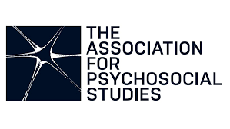
APS PSYCHOSOCIAL BODIES CONFERENCE

1st – 2nd and 9th – 10th July 2021
Online Conference Booklet with Zoom Links

@assoc4psychosoc #PsychosocialBodies
Contents
Conference Agenda 1
DAY ONE – THURSDAY 1ST JULY. 2
Overview of Day 2
SESSION ONE 3
Welcome 3
Performance Poet – Ezimma Chigbo 4
Invited Speaker – Prof. Derek Hook 4
SESSION TWO 5
Room 1 5
Ernesto Espíndola: Self-Transgressive Followership. A Lacanian Reading of Indefinite Presidential Re-Elections in View of the Ecuadorian “Citizens’ Revolution”. 5
Monica Luci: Bodies of Knowledge: Tortured Bodies and the Problem of Knowing 6
Room 2 7
Marilyn Charles: Embodied Meaning: Aesthetic Sensibilities, Primary Process, and Metaphor 7
Lita Crociani-Windland, Nigel Williams, Jonathan Mosley and Sophie Warren: Architecture on the couch: buildings as psychosocial bodies. 8
SESSION THREE 9
Room 1 9
Jack Black: ‘The Rusedski smile… Are we really that desperate for success’: English Nationalism, the Body and the Other – Making Sense of Rusedski’s ‘Smile’ 9
Liz Reilly: Embodiment and parallel processes: the post-mortem of a failed research project. 10
Room 2 11
Sally-Ann Dunn: The tears of the therapist – making meaning of a tearful response as a form of embodied knowledge of the client's experience 11
Tim Moore: Embodiment and the Value of Peer Support in Mental Health 12
Workshop 1 13
Lynn Froggett, Steffen Krüger and Jacob Johanssen: Transmissive Technologies and the Bounded Body: A Roundtable Discussion 13
SESSION FOUR 14
Room 1 14
Susanne Benzel: The Meaning of Self-Harm and its Representations on Social Media in Adolescence 14
Maria Stadnicka and Colleagues: Pandemia in Utero: The Experience of the First British Lockdown for Romanian Diaspora with Experience of Past Socio-Cultural Trauma. 15
Room 2 16
Noreth Muller-Kluits: Disability and Grief – Perspectives from family caregivers and persons with disabilities 16
Natalie Wotherspoon: The lonely diagnosis of myalgic encephalomyelitis 17
WELCOME PARTY 18
DAY TWO – FRIDAY 2ND JULY. 19
SESSION ONE 20
Social Dreaming – Lita Crociani-Windland and Nigel Williams 20
Workshop 2 21
Marilyn Charles and María Mirón: Embodiments of Maternal Absence in the Haunting of Hill House 21
Workshop 3 22
John Adlam: ‘Resistance is not futile': dynamics of assimilation and liberation in the story of Janeway and Seven of Nine 22
SESSION TWO 23
Room 1 23
Deborah Wright: As it was in the beginning, so it shall be at the end; A psychosocial perspective on spatialised dying bodies in their final rooms - the de-formation of objects and de-spatialised post-room-object spaces at the ending stages. 23
Nini Fang: ‘The Aggressive Potential and the Democratic Pulses’. 24
Room 2 25
Maria Vyrgioti: Beyond the Magic Principle: Reflections on Géza Róheim’s ‘ethnopsychoanalysis’ and implications for the trans body. 25
Hugh Ortega Breton: Creating space in confinement through movement-theatre 26
Room 3 27
Julia Segal: Talking with a damaged body. 27
Rembrandt Zegers – Embodied knowing and the non-human other, the culture nature split and the need for phenomenology in psychosocial research 28
SESSION THREE 29
Room 1 29
Nontozamo Tsetse: Exploring the Embodied Experience of HIV positive Women on Antiretroviral therapy. 29
Panagiotis Antoniadis: The ‘in-visible informant’: digital ethnographic encounters with people who live with HIV/AIDS within and against the visual economy. 30
Room 2 31
Deepti Sachdev: Reclaiming Pleasure: When a good woman becomes a revolutionary 31
Breanna Vizlakh: Decolonizing Psychoanalysis: The Therapist’s Role in Racial Rupture and Repair. 32
Workshop 4 33
Nigel Williams: Hidden migrations and journeys-does the experience have a body memory? 33
SESSION FOUR 34
Room 1 34
Andrea Nicki: Configuring the Body as Joyful in Dance Therapy and Sacred Dance Communities 34
Jana Patey: Bodies of Resistance and Social Defence Systems in Organisations: Can We Make Them Hear Us? 35
Room 2 36
Chenyang Wang: The Passivity of Seeing: A Lacanian Perspective on Pornographic Spectatorship in Virtual Reality. 36
Carla Ibled: ‘Founders as victim, founders as God’: Elon Musk, Peter Thiel and the two bodies of the iconic entrepreneur. 37
Postgraduate and Early Career Academics and Practitioners Meeting Space 38
DAY THREE – FRIDAY 9TH JULY. 39
Overview of Day 39
SESSION ONE 40
Updates from APS 40
Invited Speaker - Prof Elelwani Ramugondo 40
SESSION TWO 41
Room 1 41
Khyati Tripathi: COVID Dead Bodies in India: A Psychosocial Analysis. 41
Kanakis Leledakis: Bodies, Sociality and the Pandemic. 42
Room 2 44
Ali Darke: Between Here And There. 44
Sebastian Birch: The Body and Cartographies of self-harm. 46
Room 3 47
Christa Welsh: A Blackgirl Autoethnography of Separation and Loss: Child-Shifting and Transgenerational Trauma. 47
Mamatha Karollil: What the Ghost Wants: A Story of Intergenerational Secret-Keeping, Reckoning and Redemption in C Ayyappan’s “Spectral Speech”. 48
SESSION THREE 49
Workshop 5 49
Leslie Thompson, Sophie Savage, Lita Crociani-Windland and Marilyn Charles: Enabling and disabling displacements in the mother/daughter relationships: embodying the reparation of formative experiences. 49
Workshop 6 51
Teresa Mason: The body politics of Sheela-na-gig. 51
Workshop 7 52
Ali Roy: A walk shop: invitation to an experiment in map making and mobile working 52
The Journal for Psychosocial Studies: Getting your Papers Published 53
DAY FOUR – SATURDAY 10TH JULY. 54
Overview of Day 54
SESSION ONE 55
Social Dreaming – Lita Crociani-Windland and Nigel Williams 55
Workshop 8 56
Activist Research Collective: "All Bodies Are Equal - embodied resistance and anti-oppressive practices" 56
Workshop 9 57
Mila Kirstie Kulsa and Elan Cohen: The abject body of the psychiatric sufferer: On the medicalization of suffering 57
SESSION TWO 60
Room 1 60
Dane Isaacs: “Stammering less so that I can be more of a man”: Discourses of Masculinities Amongst Young Adult Men in the Western Cape who Stutter. 60
Sasha Shestakova: Other reproductive technologies 61
Room 2 62
Mauricio Baez: The Faces as the most Dramatic Bodies. 62
Julian Manley: The Social Dreaming Matrix as a Body Without Organs. 63
SESSION THREE 64
Trudi Macagnino: Online psychosocial interviewing: An out-of-body experience? 64
Julie Walsh, Poul Rohleder and Róisín Ryan-Flood: Holding Hands: LGBTQ relationships and experiences of shame, pride and protest in everyday spaces. 65
PLENARY 66
FEEDBACK 67

Conference Agenda
UK/ PM | Thursday 1st July |  | Friday 2nd July |  |  | Friday 9th July | Saturday 10 July
1:00 –  2:30 | Welcome  Ezimma Chigbo |  | Social dreaming  (Limited to 30 people) |  | Workshops  2 & 3 | Updates from APS | Social dreaming  (Limited to 30 people) | Workshops  8 & 9
 | Prof Derek Hook |  |  |  |  | Prof Elelwani Ramugondo
2:40 –  3:30 | Session 2:  Parallel Paper Presentations |  | Session 2:  Parallel Paper Presentations |  |  | Session 2:  Parallel Paper Presentations | Session 2:  Parallel Paper Presentations
3:30 –  4:00 | Zoom discussion with  Ezimma and Derek |  | Moodle Interactive Content |  |  | Zoom discussion with Elelwani | Moodle Interactive Content
4:10 – 5:00 | Session 3:  Parallel Paper Presentations | Workshop 1 | Workshop  4 | Session 3:  Parallel Paper Presentations |  | Workshops 5, 6 & 7 | Session 3:  Paper Presentations
5:10 – 6:00 | Session 4: Parallel Paper Presentations |  |  | Session 4: Parallel Paper Presentations |  |  | Plenary
6:10 –  7:00 | Welcome party |  | Student meet up |  |  | APS Journal Talk

DAY ONE – THURSDAY 1ST JULY.

Overview of Day

UK/PM Time | Session | Activity
1:00 to 2:30 | Session 1 | Welcome  Performance Poet – Ezimma Chigbo  Invited Speaker – Prof. Derek Hook
2:40 to 3.30 | Session 2 | Room 1:  Ernesto Espindola  Monica Luci |  | Room 2:  Marilyn Charles  Lita Crociani-Windland et al.
3.30 to 4:00 | Break Activity | Room 1:  Discussion with Derek Hook |  | Room 2:  Discussion with Ezimma Chigbo
4:10 to 5:00 | Session 3 | Room 1:  Jack Black  Liz Reilly | Room 2:  Sally-Ann Dunn  Tim Moore | Workshop 1:  Lynn Froggett, Steffen Kruger and Jacob Johanssen
5:10 to 6:00 | Session 4 | Room 1:  Susanne Benzel  Maria Stadnicka et al. | Room 2:  Noreth Muller-Kluits  Natalie Wotherspoon.
6:10 to 7:00 | Evening Activity | Welcome Party

SESSION ONE
1:00pm to 2.30pm UK time

Welcome
We would like to welcome you all to the APS 2021 conference, being held online and hosted by the University of Essex. As many of are aware, our conference in 2020 was cancelled due to the pandemic of uncertainly that COVID has brought us all. Last year we could not have conceived of doing a conference of this nature on-line, including papers from Canada, India, USA, Europe and Africa. As such we have kept a conservative amount of time for each day, and hope that it is convenient for all who are presenting and attending the 4 days. We are very grateful that many of the original presenting authors have carried forward and/or transformed their papers to be relevant for the current psychosocial concerns in 2021. Thank you too to Ezimma Chigbo, Derek Hook and Elelwani Ramugondo for sticking with us from last year and offering us their thoughts on psychosocial bodies in July 2021.
The conference committee has been supported by the excellent work of Dr. Sarah Shorrock. We are sure you have had many useful emails from, and her organising us all has been invaluable. We would like to acknowledge the APS Events group who, following the shutting down of the APS 2020 conference (in April 2020), have held APS on-line monthly meet ups, including a mini conference, keeping alive the thinking and work within the APS community.
During this time of lock downs, news of the rapid and devastating outbreaks of COVID in Brazil and India, frustrations with policy decisions (and no decisions) and the need to share resources across the world, i.e. we are not safe until all are safe, we have found moments of strange comfort. One came from a monthly message that Dr Chris Nicolson, head of department of psychoanalytic and psychosocial studies at Essex, sent in April 2020 to all PPS students and staff. He has said we are welcome to use it now. Chris wrote:
If an ‘unexamined life is not worth living’ then neither is an [un]examined crisis. The waves of tragedy of this time cannot be diminished, but the chances to live better in the future can be extended. In John Wyndham’s 1951 The Day of the Triffids, his languid British protagonist Bill Masen, reflecting on life before the collapse says: ‘Looking back at the shape of things then, the amount we did not know and did not care to know about our daily lives is not only astonishing, but somehow a bit shocking’.
We hope this conference at this time, will allow us opportunities to think together about what we did not know as well as ways of moving forward into a future that is more aware of our fundamental human need for each other.
Lindsey Nicholls, Poul Rohleder, Julie Walsh, Anthony Faramelli, Debbie Wright and Sarah Shorrock. APS 2021 Conference Committee.

Performance Poet – Ezimma Chigbo
Ezimma Chigbo is a writer and creative facilitator with a background in youth work. She specialises in working with young women involved in the criminal justice system. Her main interests are race, gender and serious youth violence which she explores through poetry, prose and articles.
Ezimma works on a freelance basis delivering Anti-racism and collective care and wellbeing training to organisations and CEO’s within the third sector. She continues her work with young women, using drama, discussion and creative writing to explore difficult topics.
She is the cohost of The Echo Chamber Podcast and has published essays on topics ranging from violence against women and girls, to drill music, all serving as love letters of exploration, celebrating upbringing, culture and identity. Ezimma will be reciting three poems.

Invited Speaker – Prof. Derek Hook
Racializing embodiment
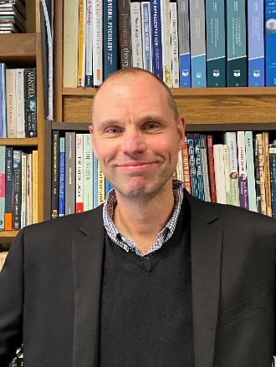
Few have evoked the disjunctive experience of racializing embodiment for persons of color in racist contexts as powerfully as Frantz Fanon. Yet while Fanon’s work on the disturbed dialectic between the body and the world is often revisited, there is a valuable supplementary analysis of race and embodiment that remains neglected: the work of the Black Consciousness psychologist Chabani Manganyi. For Manganyi, the body poses a problem both to the ego and culture. In embodiment, he argues, we see the existential dilemma of the disharmonious body-to-ego relationship as it is transformed into a pragmatic socio-cultural problem. This dynamic is particularly pronounced in white supremacist cultures: cultural/racial others are bodies, whereas whiteness is imagined as transcending the bodily and attaining the status of cultural being. Through a careful exploration of Manganyi’s blending of existential-phenomenological and psychoanalytic concepts, we will see how his work anticipates many of the central concerns of contemporary theories of racism, ranging from those of Afro-pessimism and Lacanian social theory to the rearticulations of Fanon provided by Achille Mbembe and practitioners of critical phenomenology.

SESSION TWO
2:40pm to 3:30pm UK time

Room 1

Ernesto Espíndola: Self-Transgressive Followership. A Lacanian Reading of Indefinite Presidential Re-Elections in View of the Ecuadorian “Citizens’ Revolution”.

In 2014 President Rafael Correa, a former critic of indefinite presidential re-elections and the leader of the Citizens’ Revolution, asked the Ecuadorian legislature to abolish the presidential term limits. After heated debates, the Assembly approved this reform. How can we account for the parliamentarians’ sudden decision to abolish the presidential term limits at the request of Correa, considering it was their own constitution that ratified these limits? This article undertakes a critical discourse analysis of the official argument in favour of the proposal for indefinite re-elections in Ecuador. Courtesy of Lacanian psychoanalysis, the paper contributes to our understanding of leadership by arguing that strong attachment to a charismatic leader can partly result from the followers’ inclination to transgress their own ideals.

Monica Luci: Bodies of Knowledge: Tortured Bodies and the Problem of Knowing

This paper aims at exploring through psychoanalysis the issue of the location of knowledge in societies that practise torture. More specifically, I intend to pursue the hypothesis that tortured bodies are the sites of ‘knowledge’ for ‘torturous societies’, i.e. the ‘places’ into which unprocessed social contents are stored and questioned through torture by the large national group. This knowledge can be re-traced subsequently in psychotherapy with survivors. The hypothesis is here posed through a clinical lens, looking at cases of torture survivors and observing in what directions and how the themes of therapy develop within the therapeutic interaction.
Current paradigms in psychoanalysis and analytical psychology conceptualize the mind in ‘systemic’ terms, as an emerging property of multiple self-states in mutual interaction. This systemic metaphor highlights that the mind is created and re-created at the threshold of the intrapsychic, the interpersonal and the social, processing issues of identity (difference/sameness), among others, in a sense of me-ness/we-ness. Due to the centrality of the body in the therapies of torture survivors, the conditions of social distancing and remote clinical work imposed in the last months by the Covid-19 pandemic set harsh rules for these psychotherapies, increasing the sense of the survivors’ isolation and the intensification of their complex posttraumatic suffering.
These special conditions made even more clear to what extent we are materially, emotionally, and socially embedded. The concept of embeddedness expresses the notion that social actors exist within the material, cultural, institutional, and social contexts and cannot be seen as atomized decision-makers. This prioritises the different conditions within which social action takes place.

Room 2

Marilyn Charles: Embodied Meaning: Aesthetic Sensibilities, Primary Process, and Metaphor

The body has been abject-ified in the psychoanalytic canon, in an inexorable splitting endemic in a patriarchal culture. We can find this dilemma everywhere, as in the privileging of verbal language over the nonverbal realms even while attempting to illuminate the secrets lodged within the more primary – embodied - processes.
Meaning is a psychosocial construction. Psychoanalysis, as an evolving mode of inquiry, can only be understood in relation to its origins in Freud's encounters with unconscious processes that manifested in the forms of slips, symptoms, and dreams. In his attempts to translate these more primary processes into verbal language, Freud offered the term libido as the agent of motivation that marks a desire and intention based upon primary experience. Over time, this concept came to have a sexualized connotation that spoke to some aspects of our primary drives but occluded others.
Matte-Blanco (1975) countered this tendency by looking at primary and secondary process through the lens of symmetrical versus asymmetrical logic, a language structure that more fully holds in mind the essential meanings lodged within our nonverbal, embodied capacities.
Bion (1975) describes three vertices from which 'facts' might be perceived, the scientific, religious, and aesthetic. Some theorists have described an aesthetic dimension of the mind, but I would go further, proposing that what Freud termed libido, in being a function and manifestation of the unconscious, is primarily aesthetic in form and fundamentally em-bodied.
From a psychosocial perspective, all experience involves an integration of internal and external experience, moderated by meanings that accrue at the intersection between embodied experience, sociocultural containment, and symbolic meanings. I will discuss primary process as a way of knowing self, other, and experience as informed by the aesthetic sensibilities referred to by Freud, Matte-Blanco, and Bion. This lens helps us to explore ways in which psychoanalytic metaphors refer directly to this primarily aesthetic sensibility that underlies all human knowing, and to consider how personal and clinical experience illustrate the value of this perspective in considering both theory and the larger sociocultural matrix within which what we may most truly know becomes subverted, delegitimized and abjectified.

Lita Crociani-Windland, Nigel Williams, Jonathan Mosley and Sophie Warren: Architecture on the couch: buildings as psychosocial bodies.

This paper outlines findings from an interdisciplinary project that speculated on architecture as a psychological subject. The project was based on collaboration between an architect, an artist, a psychotherapist and a psychosocial researcher The project first developed an ontological framing that considers the affective inter-relation of the human and non-human within the assemblage of architecture. The framing then allowed consideration of conscious and unconscious qualities and imprints within the built and within the designers and occupiers, generating a toolkit of methods derived from psycho-social studies, psychotherapy and conceptual art that were tuned to an architectural and multi-entity subject. Some of these methods were then tested to reveal interdependencies, affects and dynamics within one chosen architectural assemblage. Using a genealogical case study approach, the project examined an iconic public building in Paris, identified both as Espace Niemeyer and commissioned as the HQ of the French Communist Party, to track unconscious traces related to its developmental history and current impact and finding moments of contingency, conflict, haunting, loss and denial.

At the end of session two there will be a short break and an opportunity for participants to have a Zoom discussion with Ezimma and Derek.

SESSION THREE
4:10pm to 5:00pm UK time

Room 1

Jack Black: ‘The Rusedski smile… Are we really that desperate for success’: English Nationalism, the Body and the Other – Making Sense of Rusedski’s ‘Smile’

This paper will critically examine how psychosocial thinking can help to support interdisciplinary analyses of the other, and, specifically, media portrayals of the other’s body. Though it is widely accepted that media coverage plays a pivotal role in framing and positioning outsider individuals/groups, this analysis will explicitly consider how media discourses can be used to extend our understanding of the body and national identity via psychoanalytic interpretations of the other. By exploring this relationship under the theme of “Psychosocial Bodies”, this paper will identify the various ways in which the other, and their body, are framed in relation to hegemonic conceptions of what constitutes “the nation”.
These aims will be demonstrated in newspaper coverage of the Canadian-born, British tennis player, Greg Rusedski. It will be noted how media framings of Rusedski centered on a particular feature of his body – his “smile”. In order to elucidate on the significance of Rusedski’s “smile”, Lacan’s (2010) notion of the “fragmented body” will be used to critically examine how the other’s body can prove effective in helping to elucidate wider anxieties, confusions and contradictions regarding English nationalism/national identity. Specifically, analyses of Rusedski’s “post-imperial” Otherness (an Otherness which centered on his “smile”) will serve as a demonstration of the splits, voids and contradictions which underscore a coherent and constituted (national) “us”. Through their elicitation in English national newspapers, these examples will emphasise how it is through “the body” that the nation’s inherent limitations are enacted via forms of obfuscation that work to both separate and delineate the ‘other’.
It will be argued that this “limit” can be brought to bear via Lacan’s notion of the “extimate” (extimité), defined by Alenka Zupančič as “an excluded interiority or an included exteriority” (Zupančič, 2019: 90). In particular, understandings of the extimate – and its relation to a psychosocial understanding of the other, the body and the nation – will reveal how Rusedski’s “smile” provided an uncanny disturbance for the English national press; one in which wider anxieties and tensions regarding English nationalism were constructed, framed and represented.

Liz Reilly: Embodiment and parallel processes: the post-mortem of a failed research project.

When a qualitative research project looking at developing resilience in Social Workers stalled irrevocably, the remaining researchers sought to explore the mistakes that led to its failures.
The research project that had been attempted, was a longitudinal exploration of student social workers’ resilience during and after a fast-track qualifying programme.
The project had an experienced lead, a research team made up of social workers in practice and academic staff, a body of 25 students keen to participate, ethics approval and reflected contemporaneous interests in the field of social work, and the education of social workers. This project showed good signs of health, so what went wrong?
The researchers found, alongside numerous practical and logistical factors, significant psychosocial processes that had previously been unexplored or ignored. These were ‘invisible’ to the researchers during the project, and only gradually became visible afterwards.
Liz will consider this failure alongside 3 psychosocial themes:
Embodiment: we discuss how the project embodied elements of the fast track format, and moreover how it blindly incorporated many of the challenges manifest in child protection social work.
Parallel processes: a notion generally used in psychodynamic supervision, we use this to illuminate not only interpersonal factors between members of the research team, but also processes mirrored at government, academic and practice levels.
Post-mortem and pre-mortem: we consider the role of a reflective ‘post-mortem’ in identifying under-the-surface processes at work in this research, and their potential use in future research and practice. We muse on the possibilities of ‘pre-mortems’ in research planning.
The findings suggest the likely underreporting of psychosocial influences within research, even when psychosocial realities are the intended subject of the research. Ignoring these processes pose a risk to the successful planning and completion of a project and will necessarily influence results.

Room 2

Sally-Ann Dunn: The tears of the therapist – making meaning of a tearful response as a form of embodied knowledge of the client's experience

As therapists we make use of all aspects of ourselves to help understand our clients' experiences of themselves and the world. A central aspect of this is our countertransference – a psychoanalytic concept which acknowledges that our thoughts and feelings in response to being with and listening to our clients can be a useful tool in understanding them at a deep and unconscious level. Together with thoughts and feelings attention is paid to the variety of somatic and bodily responses we encounter. These give clues to the mind/body link within our clients and ourselves, furnishing us with a form of embodied knowledge relating to the client's experience.
A type of embodied knowledge about which little is written in psychoanalytic literature but which has been shown to happen in practice, anecdotally and in several research studies, is when a therapist experiences a tearful response to an aspect of their client's material in a session. Unlike most forms of bodily countertransference response, a time when the therapist's eyes fill with tears is one where the therapist's response is visible to the client. This results in a challenge and opportunity in the work and for the therapeutic relationship. A small research study I undertook to discover more about six therapist's lived experience of the times a tearful response had occurred in their work, and how it might confirm and/or challenge my own thoughts, led to further understanding about how meaning might be made of this particular form of embodied knowledge.
Tears have been thought about in different ways over time and it seems clear there are psychosocial overlaps in history's perceptions of their meaning. Crying and tears are our first means of communicating our bodily and emotional distress and we grow up in families and cultures that give us messages that will affect our relationship to our own tears as we develop. These messages are held within the mind/body and the times a therapist experiences a tearful response offer a chance for this non-verbal, bodily form of communication to be explored and thought about in relation to the client's inner and outer world experiences.

Email: twcc.sallyannd@gmail.com

Tim Moore: Embodiment and the Value of Peer Support in Mental Health

This presentation summarises part of a Research Masters project exploring resistances to service user involvement in mental health services. The project involved interviewing mental health professionals about their experiences of user involvement, which were primarily of peer support workers. Peer support workers make explicit use of their own experiences of mental health difficulties to support those currently in difficulty. The first section of the analysis, described here, explored professional’s perceptions of the value of peer support.
Participants valued the quality of relationship that peer support workers brought to their work, a quality that could not be achieved by other professionals. Peers also represented a challenge to traditional discourses prevalent within mental health services, for example promoting social models of mental health over medical models, and this was also valued by participants.
Both these aspects of the peer’s work were dependent upon the physical, embodied presence of the peer. The emotional impact of the relationships formed by the peer could only be fully appreciated by directly witnessing the peer at work. Their challenge was also linked to their physical presence as, without needing to speak, their being present could produce or amplify a pre-existing criticality towards certain practices within services. Participants described how this criticality was experienced emotionally, for example evoking a sense of shame in response to practices which failed to take adequate account of the subjective experience of service users.
If it can be properly supported, user involvement has the potential to represent a constructive challenge to values operating within mental health services which promote objectivity and associated forms of knowledge, and which risk eclipsing the subjective experience of mental health problems. It can do this by promoting the value of experiential knowledge and empathy, both essentially subjective processes linked to embodied presence. But this embodiment, so intrinsic to the perceived value of Peer Support, implies a vulnerability. In organisational cultures which demand the demonstration of value in abstract, quantifiable terms this kind of value can become invisible, hence putting the peer support worker role at risk.

Workshop 1
4:10pm to 6:00pm UK Time

Lynn Froggett, Steffen Krüger and Jacob Johanssen: Transmissive Technologies and the Bounded Body: A Roundtable Discussion

The past year we have witnessed the mass immobilisation of bodies while technological vectors have expanded digital communication exponentially. For many online interaction has lost its formerly instrumental quality opening while mediated relationality has become a banal fact of everyday life. Love and work, sex and death no longer imply the corporeal presence of the other while machines have gained a new authority in modelling human futures. Christopher Bollas sees in these modes of living and relating the emergence of transmissive selves - perpetually ‘switched on’ and open to the instantaneous intrusions of messaging, snapping, videoing, mailing, zooming …What then happens to selves oriented by bodies bounded in time and space and human capacities marked by the materialities of location, duration, attachment possession and destruction. Is there a friction between the emotional complexes of the transmissive and bounded self? Do they interpenetrate, colonise or erase one another? Do they offer similar possibilities for empathy, grief, joy, and connection?
This panel discussion will approach the broad question through a series of short provocations and discussion offered by the three speakers before opening the questions up to the floor.
Lynn Froggett will consider the valorisation of ‘immersive experience’ drive by the burgeoning use of Virtual Reality and the aesthetic of flow associated with video-games.
Steffen Krüger rereads existing psychoanalytic theories of narcissism (Freud, Green, Lacan, Kohut, Winnicott etc.) against persisting public and academic discussions on self-image practices on Instagram, which are seen to lead either to bloated visions of grandiosity or seriously diminished self-esteem. Far from such extremes, coordinating the theories of narcissism with current media-studies research into image-making, editing and publishing on social media platforms offers fine-grained possibilities of delineating the various positions and relations between the transmissive and the bounded self and the ways these two constructs can be seen to keep bleeding into each other.
Jacob Johanssen discusses the current state of artificial intelligence. It has often been pointed out that current AI has the mental capacities of a four-year-old child. Drawing on wider psychoanalytic work on childhood, he asks what the conceptualisation of AI as child-like reveals about our own subjectivity and fantasies about AI.

SESSION FOUR
5:10pm to 6:00pm UK time

Room 1

Susanne Benzel: The Meaning of Self-Harm and its Representations on Social Media in Adolescence

Most studies detect a larger prevalence of self-harm for female than for male adolescents. Typically, the acts of self-injury start between age 13 and 14 and therefore interestingly coincide with the beginning of puberal developments. For adolescence as well as acts of self-harm, the body has a huge significance. To deal with and to acquire the female puberal body during adolescence is connected to constitutive conflicts (cf. King 2003), which represent a focal point for body-related (destructive) coping-strategies. Thereby, not only individual-biographical, but also social and gender-specific conflicts are settled on the body (cf. Gerisch/King 2008; King 2011). In this respect, the individual act of self-injury is seen as an expression of psychosocially entailed adolescence- and gender-specific conflicts, which are settled on the body (cf. Benzel 2019).

Furthermore, the forms of self-injury have changed since the rise of the internet at the turn of the millennium: There has been an increase in private homepages and social media on which pictures of wounds and scars are posted. Some of the pictures are shocking, others seem glorifying, for example when a razor blade is photographed against a sunny background. Painful and aggressive potentials - as expressed in self-injuries - can also be communicated and attempted to be overcome in pictorial form. In addition, forums are used to exchange information about the practice of self-injurious behaviour.

In this talk, the question of the meaning of the body for young women who harm themselves will be in the center. This will be discussed 1) through interviews of my completed dissertation in a perspective, using the theory of adolescence and of biography as well as psychoanalytic-sociological approaches and 2) through analyses of posted pictures and comments about self-harm on social media.

Maria Stadnicka and Colleagues: Pandemia in Utero: The Experience of the First British Lockdown for Romanian Diaspora with Experience of Past Socio-Cultural Trauma.

On 23rd March 2020 as the United Kingdom reported 6,650 cases of COVID-19 and a death toll of 335 people (Beaumont, 2020; Stadnicka, 2020), the British Prime Minister announced the first lockdown in Britain as a measure to stop the spread of the virus (Johnson, 2020, 1’59’’). This study explores the first experiences of lockdown, shared by the Romanian ‘Children of the Decree’ currently settled in Britain. The ‘Children of the Decree’ (Wilson Centre, 2006; Dóczy, 2010; Georgescu, 2015) describes the generation of people born in Romania between 1967 and 1989. At the height of the Cold War, Romania was ruled by the Communist Party and followed the soviet model adopted in East Europe after the Second World War. The Romanian dictatorship differed from other communist models through its despotism and its strict control measures imposed on population (Câmpeanu, 1986; Nelson, Fox & Zeanah, 2014). Between 1977 and 1989 the ‘Children of the Decree’ experienced a socio-cultural trauma (Stein, 2012) marked by severe food rationalisation, travel restrictions and prolonged periods of imposed curfew. Examining interviews conducted between March and May (2020), this study acknowledges that the lockdown, followed by the panic buying, contributed to a reactivation of childhood memories during communism. The lockdown was perceived as a familiar experience by the Romanian diaspora and described as a ‘historical repetition’ (Gordon, 2008). Moreover, to the ‘Children of the Decree’ with experience of past socio-cultural trauma, the lockdown travel restrictions ignited a deep degree of mistrust in the British government and a palpable fear of losing personal freedoms.

Room 2

Noreth Muller-Kluits: Disability and Grief – Perspectives from family caregivers and persons with disabilities

Disability is often perceived negatively not only by society but also in some cases by the person with the disability self and their family members. People who acquire a disability later in life, often go through emotional experiences similar to the stages of grief identified by Kübler-Ross (1972). Similarly, parents of a child with a disability may also have a similar experience. In both cases a sense of “loss” might be felt in terms of the life planned and having to adjust to a life with a disability. In two South African-based studies with family caregivers of persons with physical disabilities and adults with acquired physical disabilities’ respectively, a sense of loss was perceived similar to the phases of grief identified by Kübler-Ross (1972). These phases include denial, anger, bargaining, depression and acceptance. These findings of these qualitative studies will be discussed also in its relation to similar previous studies. These phases have already been identified a few decades ago in a New York University Hospital study with persons who acquired paraplegia, where a four-stage process similar to stages of grief identified by Kübler-Ross (1972) was identified for PWDs coming to terms with their disability. There were correlations between the two South African studies with family caregivers and persons with acquired disabilities in having to come to terms with the life with a disability. Discussing disability in terms of “loss” and grief have been criticised in the past. However, these two South African studies have emphasised how the effect on the person with the disability and their family cannot be overlooked as well as the importance of acknowledging the phases similar to grief the person will experience. Recommendations and conclusions include how to support the person with the disability and their family in reintegration back into society to assist with living a life with a disability.

Natalie Wotherspoon: The lonely diagnosis of myalgic encephalomyelitis

Loneliness has in recent years transformed from being a private yet painful individual experience to a public health concern, particularly since the emergence of COVID-19 and the associated government social restrictions. Loneliness has been proven to have serious consequences for the health and wellbeing of individuals.
This paper shows how labelling can provide legitimacy to physical suffering while paradoxically being laden with stigma. The stigma and physical symptoms of chronic fatigue syndrome/ myalgic encephalomyelitis (CFS/ME) will be shown to amplify the loneliness and social isolation that is commonly experienced with chronic illness. The findings are drawn from 42 semi-structured interviews with people who have been diagnosed with CFS/ME in the United Kingdom. The paper also draws from my historical archival analysis of the diagnostic ancestors of CFS/ME, namely neurasthenia and the Royal Free Disease.
In this paper I will show how the participants experienced the symptoms of ME as being physical and unambiguously real while others doubted their suffering and mental state. I demonstrate that the outcome of this paradox was “epistemological purgatory” (Barker, 2005) and “diagnostic limbo” (Straus & Corbin, 1988) which led the participants to question their mental state when faced with doubt from their social network and healthcare professionals. Clinicians withholding an CFS/ME diagnosis and psychologising symptoms further fuelled self-doubt and stigma. The stigma of CFS/ME was found to have derived from a long association with mental illness and debate over the reality of the condition. The physical symptoms and stigma of CFS/ME necessitated social withdrawal, which amplified the participants’ sense of loneliness and social isolation.
This paper is the first piece of research to explicitly address the issue of loneliness in relation to CFS/ME. I argue that in the case of CFS/ME, loneliness and social isolation are experienced as the same state. By situating loneliness and social isolation within the context of living with a contested chronic and disabling illness, this paper seeks to make an original contribution to the subfield of the sociology of diagnosis.

WELCOME PARTY
6:10pm to 7:00pm UK time

Join the APS Conference Committee and Executive team for virtual introductions and catch up. Although it will not be the same as a physical party, please feel free to bring along your own refreshments and updates on what you have been doing over the last 12-months.

DAY TWO – FRIDAY 2ND JULY.
Overview of Day

UK/PM Time | Session | Activity
1:00 to 2:30 | Session 1 | Social Dreaming  Need to Register |  | Workshop 2:  Marilyn Charles and Maria Miron | Workshop 3:  John Adlam
2:40 to 3.30 | Session 2 | Room 1:  Deborah Wright  Nini Fang |  | Room 2:  Maria Vyrgioti  Hugh Ortega-Breton | Room 3:  Julia Segal  Rembrandt Zegers
3.30 to 4:00 | Break Activity | Moodle Interactive Content
4:10 to 5:00 | Session 3 | Room 1:  Nontozamo Tsetse  Panagiotis Antoniadis | Room 2:  Deepti Sachdev  Breanna Vizlakh |  | Workshop 4  Nigel Williams
5:10 to 6:00 | Session 4 | Room 1:  Andrea Nicki  Jana Patry | Room 2:  Chenyang Wang  Carla Ibled
6:10 to 7:00 | Evening Activity | Student Meet Up

SESSION ONE
1:00pm to 2.30pm UK time

Social Dreaming – Lita Crociani-Windland and Nigel Williams

Social Dreaming workshops were originally developed by Gordon Lawrence as a means of consulting to organisations in a way which could go ‘beneath the surface’ to the unconscious preoccupations, images and phantasies that are ever-present but often unsurfaced in organisational life. Since then Social Dreaming has been developed in ways which take it outside of organisations and into community and community research. Social Dreaming is an experiential event in which we offer dreams and free associate to them to work towards a collective sense of patterns emerging from them. By pooling and connecting our dreams and associations we aim to ‘take the pulse’ of broader social realities and surface common concerns and creative possibilities.

The space for coming together to share and explore our dreams through an associative process is known as a 'matrix'. The word 'matrix' comes from the Latin for womb, and is used to denote a place of containment for creativity and emergence. A "host" provides support to the matrix, guiding our journey in sharing, associating to and making sense of our dreams. The word "host" is used to introduce the idea that the matrix is not a group to be facilitated or led but an open space for containing and working with dreams and associations.
The time is spent in two phases, an initial event in which participants share dreams and associations and a reflection event in which participants do sense making of the material that arose during the matrix. The total time of the event is 1.5 hrs. The dream matrix is roughly twice the time of the reflection.

Normally the event is held in a dedicated space with a particular arrangement of chairs, known as a snowflake pattern, which distinguishes it from other group relations events. In this time of social distancing the online event is held using Zoom. This gives a different challenge in that the physical arrangement facilitating the focus to be on dreams and not dreamers is not available. Please feel free not to use video if that becomes a distraction from the dream images being shared or the emergence of free associations to them, which are key to the event.

Event limited to 30 participants – if you would like to attend this workshop, please register here.

Workshop 2
1:00pm to 2:30pm UK Time

Marilyn Charles and María Mirón: Embodiments of Maternal Absence in the Haunting of Hill House
Psychoanalysis has long recognized ways in which unprocessed trauma and unresolved mourning course through the narratives of later generations, often experienced as ghosts or phantoms that haunt an individual in profound but enigmatic fashion. The disembodied meanings communicate themselves through the nonverbal channels passed along from parent to child, becoming, oddly, embodied, informing both identity and one’s being-in and being-with the world. In this way, the ‘phantom’ marks the place of important aspects of the psychosocial context that have gone missing in the family narrative. In this panel, we will discuss the series Haunting of Hill House as offering representations of traumatic enactments that can be traced to ghosts left in relation to profound maternal absence. Coming from the disparate vertices of a young woman who has never become a mother and an older woman who has been both mother and grandmother, we will offer our very different perspectives on the character of the mother in this series. Our conversation will be informed by a recognition of ways in which the intergenerational transmission of trauma, unmourned, manifests in embodied forms in the symptoms that erupt in successive generations. From this perspective, we can contextualize the symptom as an embodiment of a psychosocial phenomenon that haunts us to the extent that it cannot be faced. Further, we can see ways in which what is not faced together become virtually unknowable in its dis-embodied form. As plays out in the television drama, it is only when the parental function is reinstituted, and mindfulness insisted on, that the embodied/disembodied symptoms can be recognized and the challenges in living managed.

Workshop 3
1:00pm to 2:30pm UK Time

John Adlam: ‘Resistance is not futile': dynamics of assimilation and liberation in the story of Janeway and Seven of Nine

‘Mental health policies should address the “power imbalance” rather than “chemical imbalance” ... and abandon the predominant medical model that seeks to cure individuals by targeting “disorders”.’ (UN Special Rapporteur (2017))

'Anorexia nervosa' is widely considered to have the highest mortality rate of any psychiatric disorder. Numerous women (and some men) die yearly of the sequelae of malnutrition and starvation. Although iatrogenic harm from inpatient treatment is seen as a high risk factor, hospital admissions for eating disorders in the UK 2017-2019 rose by 37% across all age groups.

In 2018/19, women accounted for 92% of all admissions for anorexia and bulimia of people aged 19 and over. Practices of starvation - the publication of distress in and by means of the body - elicit coercive system of care responses (both anthropophagic and anthropoemic). Multiple medico-legal technologies are deployed, in pursuit of saving lives, to coerce compliance with treatment regimes centred upon refeeding.

In these circumstances, notwithstanding many innovations in the field, there is little in the status quo to feel reverent towards. Controversy surrounds the finding, strongly asserted by the Special Rapporteur, that coercive psychiatric practices of any kind are in contravention of the UN Convention on the Rights of Persons with Disabilities (explicitly understood to include psychosocial disabilities such as eating distress). Bodies, alas, are the battlegrounds on which these discourse wars are fought, often to the bitter end.

I propose that the existing diagnostic and treatment frame for 'eating disorders' is inadequate and needs to be challenged. I deploy the story of how Captain Janeway reclaims Seven of Nine's humanity from the Borg in Star Trek: Voyager as a parable in order to explore responses of systems of care to the dangerous otherness attributed to 'disordered' practices of starvation and the ethics of 'colonial' (anthropophagic) and anti-'colonial' (resistant) practices in fraught encounters between in-groups and out-groups. I conclude by imagining something of what our societal responses might look like if we began by accepting, as axiomatic, the ruling of the UN Special Rapporteur.

SESSION TWO
2:40pm to 3:30pm UK time

Room 1

Deborah Wright: As it was in the beginning, so it shall be at the end; A psychosocial perspective on spatialised dying bodies in their final rooms - the de-formation of objects and de-spatialised post-room-object spaces at the ending stages.

I discuss a psychosocial perspective on dying and dead bodies within their final room spaces, where the relinquishing and de-formation of objects and de-spatialised room-objects can lead to post-room object spaces. I have argued that a part of the formation of objects is spatialisation. The term ‘spatialisation’ (Shields 1991) has been used to describe social meaning related to spaces. I use the term ‘spatialisation’ (Wright 2019), not only for the purpose of ascribing meaning to space, but also to refer to the psychological and physical mechanisms by which this happens, as well as for the motivation behind its use. Spatialisation simultaneously involves a psychological projection of meaning and physically acting upon the environment, utilised to master the undifferentiated, relentless, internal pressure of instinct. I suggest that this can take place within a matrix of stages, the first of which takes place into mother/parts of mother to create the object, this is pre-object and therefore pre-transferential. I suggest that a difficulty in utilising mother as the first object of spatialisation, can lead to spatialising into the spatial array of room spaces with the objects within them replacing or supplementing the mother function. I argue that the end of this room- spatialisation process is the spatialising of dying bodies in their final room spaces at the end of life. I argue that this can involve the opposite process to that which happens at the beginning of life, where objects are constructed/formed in order to function. Here, in this final room, the objects can be de-constructed/de-formulated, and the room-objects are likewise de-spatialised, as if returning to being unborn or unliving. Henri Gide gives an account of his dying mother, that illustrates the de-formation of objects that I argue can lead to the de-formation of room-object spaces. I look at Sigmund Freud’s relationship with his last room space. Lastly, I consider the dead body in its final, post-life, post-object room space and how that can be thought about in terms of room-spatialisation. I consider Kantorowicz’s effigies in the walls of rooms spaces and their functioning, as well as death masks in this post-room-spatialisation stage.

Nini Fang: ‘The Aggressive Potential and the Democratic Pulses’.

Perhaps little more can disillusion the stereotypical consolation illuminated near the lantern of Eastern femininity than her expression of anger. While literature on intersectionality exposes how racism and sexism go hand in hand in producing the subject as the multiply discriminated object (c.f. Ahmed, 2001; Cheng, 2006; Tummala-Narra, 2007), less is on how the racialised and sexualised bodies host also affective agents who mobilise affective stirrings against Otherness. In this paper, I write into an intersectional depth through auto-ethnographical revelations as an Eastern Asian woman living in the UK, examining specifically the culturally mediated charges, prohibitions and articulations of anger that cohere around the embodied practices and presensing of Eastern femininity. Tapping into a less-explored area of aggression and aggressive potential in Winnicott’s work, I draw attention to the place of anger at the site of cross-racial encounters and the aggressive potential as oppositional forces against the representational barriers placed before the Asian woman barring her as the ‘ghost-like’ other - who “switches between the thingness of persons and the personness of things” (Cheng, 2017).

For Winnicott, an equation should not be made between aggression and reactive anger. Whilst the latter points to an un-reflexive mode of acting out, the former captures the sense of “developmental struggle” (Eigen, 1981) of breaking out of the shell, hence breaking out from the non-differential engulfment of me and not-me. Aggression, in this sense, can be reframed as a defensive strategy of the marginalised other against homogenous control, of psychical labour to break from the domain of cultural complicity that seeks to hold all its beauty and ugliness within the inorganic ‘thingness’ of an epidemiological shell. In other words, aggression can be reframed as forces of ‘creative destructiveness’ required in order to subvert “the apparent gestures of mastery and certitude behind every production and assertion of the stereotype” (Cheng, 2006: 101) and re-organise the social, interpersonal and institutional latitudes into democratic spaces so that the subject ventures a break from the grip of colonial fetishisation, laying bare politics of recognition made vivid by the Western conceit of colonial supremacy.

Room 2

Maria Vyrgioti: Beyond the Magic Principle: Reflections on Géza Róheim’s ‘ethnopsychoanalysis’ and implications for the trans body.

Géza Róheim (1891-1953) was the first psychoanalytically trained anthropologist mostly known for undertaking fieldwork in indigenous tribes in Australia, Melanesia and North America to explore the universality of Freud’s theory of the Oedipus Complex. In this paper, I turn to Róheim’s posthumously published work, Magic and Schizophrenia to think about magical thinking as a form of an embodied ‘mastering’ of reality. Róheim’s theory of magic differs from what is traditionally articulated in psychoanalytic thought as a withdrawal from reality (e.g., schizophrenia). Instead, what Róheim proposes is a theory of secondary narcissism that demands to have a say over reality and claims a necessary negotiation with it. Overall, I aim at offering some preliminary insights that potentially reach beyond the orthodox psychoanalytic theorisation of the omnipotence of the trans body and I argue that Róheim’s theory enables us to represent the ways in which the trans subject mobilises imagination and magical thinking in the field of possibility.

Hugh Ortega Breton: Creating space in confinement through movement-theatre

This paper will explore the extent to which movement combined with applied theatre produces new spaces for thought and action in confined settings. It is based on a 3-4 day workshop delivered in prisons and secure care units, and a recent practitioner workshop which tried to make sense of exactly what happened and how. The workshop combined applied theatre techniques with contemporary dance, with the explicit aim of reducing physical violence through a ‘trauma-informed’ approach. During the course of the workshop we observed a dynamic relationship between movement and discussion exercises.

Frigon (2009, 2012) has described “how the confined body can achieve some spaces of ‘freedom’ through performance; and reclaiming, albeit temporarily, the space of confinement”. I will discuss how bodily movement can create a time and space-bound experience of greater room for thought, talk and action in these contexts; not through performance but primarily through physical self-expression, reflection and the careful facilitation and holding by practitioners. This concerns the dynamic interplay of physical movement and its affective experience in movement exercises, and discussions about difficult feelings in real relationships.

Room 3

Julia Segal: Talking with a damaged body.

When I suggested a title for this paper which included the words ‘damaged body’, I was warned this might cause controversy. The word ‘loss’ in connection with the effects of Multiple Sclerosis (MS) was equally deeply controversial when I started work for a self-help charity for people with MS in 1983. Objection to the easy use of these words is well-founded. To imply that a ‘loss’ or ‘damage’ is the defining feature, or perhaps even, the sole significant feature of having MS or any other health condition is a serious mistake on many levels. Loss and damage are generally classified as ‘bad’, and it is easy to make the (thoughtless, unconscious) elision to a sense that the person demonstrating either is themselves bad, or has done something to deserve punishment: a thought that may be defended against by idealisation. It undervalues and distracts from the goodness, strengths, the normality and the everyday nature of bodies (and minds) which function differently.
Taking all this (and more) into account, I think there is a place for considering the way physical bodies affect people, both consciously and unconsciously, including their interactions with others. My work (as a counsellor for couples and individuals) has been mostly with people affected by neurological conditions, and it is clear to me that, where bodies show signs of neurological damage, relations with the self and with the world are affected. In my talk and in the discussion, I will examine some of the ways in which this happens; in particular the ways it can affect people’s understanding of themselves and others.
Illness and damage to the body makes people feel ‘bad’ in many ways. Understanding some of the ‘badness’, putting it in context, can help to reduce some of the barriers to mutual understanding when we are presented with evidence of a damaged body, whether our own or someone else’s.

Email address: juliasegal@mscounselling.com

Rembrandt Zegers – Embodied knowing and the non-human other, the culture nature split and the need for phenomenology in psychosocial research

Conscious reference to relating to nature is largely absent from socio economic thought and not valued in most professional working cultures and how they are reproduced. I assume this to illustrate the culture nature split in Western think-ing. As long as that split continues our existence is at stake, as the sustainability crisis demonstrates. Do we need ‘the body’ to solve the sustainability crisis? I argue that to be the case.
I question current sociopsychological ontologies and epistemologies to be able to solve the culture nature split. I want to show that understanding nature psy-chosocially is different from understanding it phenomenologically. From there I argue researching relating to nature needs cooperation or at least a conversa-tion between the psychosocial approach and the phenomenological approach of researching relating to nature. My presentation will be around this argument.
In the first part of my presentation, I will show (from my own research) different findings in the research of relating to nature depending on either psychosocial analysis or phenomenological analysis. In the second part I discuss notions of the self, showing three different directions, from developmental psychology/psy-choanalysis, ecopsychology and anthropology of indigenous people. In the third part I talk about the question if we need the body to understand nature (re. ‘solve’ the sustainability crisis). That is an argument for a dynamic relational practice of ecocentric ethic, instead of a static one, through one’s body as ‘a tool’ in communicating with nature. Such comes with dynamic meaning making as a continuous process at the core of the practice of relating to nature.

SESSION THREE
4:10pm to 5:00pm UK time

Room 1

Nontozamo Tsetse: Exploring the Embodied Experience of HIV positive Women on Antiretroviral therapy.

The introduction and general usage of highly active antiretroviral therapy (ART) have extremely changed the history of human immunodeficiency virus infection and acquired immune deficiency syndrome (HIV/AIDS) from a deadly condition to a manageable chronic disease. Despite the great success of antiretroviral therapy in managing HIV, women taking the treatment have also reported several adverse drug reactions to it, particularly those pertaining to body alterations which produce a body that appears ill. The antiretroviral therapy side effects are fundamental to the experience of living longer with HIV but rarely have they been studied. Research linked to side effects were mostly conducted in Western countries which has left a gap in the embodied experiences of side effects among women living with HIV/AIDS in Sub-Saharan Africa. Especially considering that women’s bodies are perceived by a number of people as sex objects, as objects of beauty and are subject to continuous evaluation and judgment, which may make it more difficult for women living with HIV to attain a comfortable embodiment. This study aims to explore how women living with HIV experience their bodies, focusing on the embodied side effects of being on antiretroviral therapy. Eleven HIV positive women living on antiretroviral drugs for the period of 2 years and more were interviewed using phenomenological semi-structured interview method. Their ages ranged from 26 to 60 years. The data was analysed using interpretative phenomenological analysis. The analysis of data revealed five main themes: loss of the self, body viewed as ugly, damaged and dangerous, loss of control over the body, body conscious in social setting and body experienced as abnormal. Therefore, the disruptions evoked by the side effects of antiretroviral treatment call for adjustments as women come to terms with their altered body, deterioration of the body's capabilities, a disruption to the embodied positioning to the world and everyday activities.

Panagiotis Antoniadis: The ‘in-visible informant’: digital ethnographic encounters with people who live with HIV/AIDS within and against the visual economy.

My research project is a psychosocial study of sexual intimacy as an ethicopolitical encounter ethnographically grounded in the post-HIV/AIDS queerscapes of Greece. Due to the Covid-19 public health measures, I was forced to re-attune my phenomenological and psychoanalytic mode of attention, since both the field itself and the ethnographic encounters with my informants have been inadvertently mediated by the new bio- and psycho- political regime. The turn to digital ethnography, especially in the case of my interlocutors who live with HIV/AIDS, and the concomitant phenomenological reorientation required of me has proved to be fruitful in terms of problematizing the occulocentric assumptions of the methodological tools I use to collect my ethnographic data as well as of the analytical notions I borrow from the psychoanalytically informed theory in order to interpretate the former. More generally, I call for a mode of critique that exposes not only the cognitive, but also the implicit sensorial assumptions embedded in the conceptual personae and key notions that populate the pages of HIV/AIDS-related queer theory.
In this paper, drawing from the ethnographic data mined from a series of techno-mediated interviews I have conducted with invisible -indeed faceless- informants, I discuss the gaze as a fantasy frame which orchestrates the serophobic symbolic by foreclosing the traumatic real as the invisible, that is in its sensorial modality of visuality, and not as a signifier as usually perceived. The gaze is also treated as the ambivalent object of desire that sheds light on the passionate and traumatic attachments of seronegative subjects to the ethicopolitical ideal of safer sex, the affective and the libidinal driving behind the normative violence of serophobia.
Within this context, I make the case for a psychosocial account of stigmatization as a form of symbolic violence that structures the field of vis-ability by -paraphrasing the Foucauldian maxim- making some bodies visible and letting others be invisible. For this purpose, I use the notion of derealization and the hypothesis of the theft of enjoyment by Judith Butler (2004) and Slavoj Žižek (2005) respectively, critically reread in order to unearth the implicit visual economy that is operative behind their cognitive argumentation in an attempt to analyse the multi-layered interconnections among visuality, desire, and violence.

Room 2

Deepti Sachdev: Reclaiming Pleasure: When a good woman becomes a revolutionary

In this paper, I examine the anxieties and prohibitions around pleasure and touch that regulate the sensuous lives of Indian women. The cultural narrative of the ‘good woman’ foregrounds her role in the relational matrix as a mother and wife, emphasizing self-denial and self-sacrifice as virtues to uphold. This denial of the self is located especially in the denial of those needs and desires that center around her body. At the same time, traditional Hindu culture equates womanliness and femininity with pleasure and sensuousness, treating woman as an exciting-rejecting object that is ultimately an impediment in one’s spiritual journey - ‘maya’ that must be overcome (much like instinctual renunciation) as one moves towards a more enlightened state of being. While modern attitudes in this respect are relatively relaxed and less phobic towards the erotic woman, nevertheless the dichotomizing discourse of good touch and bad touch, especially the heightened patriarchal anxieties in the wake of the recent metoo movement, assumes erotic experiences to be flat and two-dimensional while overemphasizing the passivity and helplessness of the woman. The paper discusses some clinical case vignettes to explore the silences that operate in the experience and articulation of sexual and sensual pleasure in women’s lives. It asks what is it about the psychoanalytic setting that mimics the dominant cultural anxieties? How are we as therapists to tease apart the resistances and silences that abridge our bodily lives and enable a movement towards the positive possibilities of wording and worlding our experience – articulation, exploration, reflection, play and re-creation of symbolic meanings. The paper argues that psychologically exploring and experientially integrating the body as a site for pleasure is a significant part of arriving at the subjective sense of agency through which a woman can claim her place in the world.

Breanna Vizlakh: Decolonizing Psychoanalysis: The Therapist’s Role in Racial Rupture and Repair.

Over the past year, the nation endured unimaginable trauma as the United States experienced a surge of racist and xenophobic violence and the country fractured along political fault lines. This wave of divisiveness illuminated the deeply ingrained systemic racism that pervades everyday life in the United States and renders it impossible for anyone to be entirely neutral in their relationships with others. This includes clinicians, as research has demonstrated that implicit bias toward marginalized groups inevitably contributes to disparities in diagnosis, treatment, and outcomes. This contributes to clinicians’ misattunement or misunderstanding of their clients’ identity, which can lead to tension, deterioration, and potentially irreparable breakdown of the therapeutic relationship, otherwise known as a rupture. The critical element that defines this type of rupture is power: the therapeutic relationship is hierarchical by nature, and the interwoven components of identity contribute to the power differential in the therapeutic relationship.
Acknowledging systems of oppression and their influence is an essential aspect of addressing and repairing this rupture. It is necessary to approach therapy with a strong understanding of the intersectionality of marginalized identities, as those who hold minority status in multiplicity can be simultaneously impacted by a variety of oppressive schemas. The therapist must recognize their positionality within these systems and how that may contribute to tension within the therapeutic alliance. A critical-cultural-relational approach which examines the broader context of the rupture is essential for remediation. This paper will address the significance of racial and cultural trauma, implicit bias, and the process of healing the damage of this rupture to rebuild a mutually vulnerable, compassionate, and culturally-attuned alliance.

Workshop 4
4:10 to 6:00pm UK Time

Nigel Williams: Hidden migrations and journeys-does the experience have a body memory?

In this workshop I will share some of my findings about the experience of migration and diaspora when embedded in family and ethnic histories that maybe “known” but unexamined. Drawing on my recent book’s research findings (Williams, N 2021 Mapping Social Memory a Psychotherapeutic Psychosocial Approach) I will explore some of the forms that memory can take when social and cultural dislocation are part of an individual or family history. I will offer ideas about the cyclical nature of some of these memories that also offer a way of working with them. There will be some reflective experiential work as part of this workshop.

SESSION FOUR
5:10pm to 6:00pm UK time

Room 1

Andrea Nicki: Configuring the Body as Joyful in Dance Therapy and Sacred Dance Communities

Counselling and psychotherapy for incest survivors have traditionally been based on a mind-body duality, with talking cures designed to help survivors manage their thoughts, emotions, and behaviours, and less attention given to their relationships with and experiences of living in their bodies. Research on female incest survivors perpetuated by males and autobiographical narratives show that survivors can experience more bodily shame, more anxiety about bodily experiences, and more discomfort with invasive health care treatments (e.g. maternity care, pap tests). The few studies done on female incest survivors and group dance therapy have shown that such therapy can help survivors feel more positive about their bodies, more attuned to bodily and emotional needs and limitations, and more trust in touch. Dance therapy can help survivors work through and dissolve strong negative emotions associated with past and current life challenges such as anger, hate, shame and guilt.
I present my own personal narrative of my experience with movement medicine and sacred circle dance. Movement medicine, a contemporary freestyle eco-spiritual dance practice open to all abilities and levels, directs participants to explore a wide range of negative and positive emotions and promotes pleasurable feelings of embodiment and a greater sense of self, family and home. Workshops focus on themes such as working with emotions and the elements of earth, air, water, fire; exploring sexuality and masculine and feminine archetypes; celebrating holidays in ancient, earth-based religions; and honouring ancestors. Similarly, sacred circle dance has no emphasis on assessment or performance and fosters the virtues of humility, empathy, kindness, and inclusiveness. As in movement medicine, there are no "wrong steps," and circles, which have weekly meetings, provide a sense of security and stability. Participants in movement medicine and sacred circle dance, as members of loving dance tribes, can enjoy a positive social identity. I explain how my regular participation in these dance forms has helped configure my body as a site of pleasure and joy while also exploring some limitations of these dance forms. As facilitators of movement medicine encourage reflective, narrative writing as a way to integrate bodily knowledge, some of my personal narrative is in the form of eco-spiritual poems, and I share these with analysis.

Email: nicandr4@aol.com

Jana Patey: Bodies of Resistance and Social Defence Systems in Organisations: Can We Make Them Hear Us?

Almost 60 years have passed since Menzies Lyth (1960) famously demonstrated through a nursing study how organisational ‘social systems’ can function as collective defences against employees’ anxieties, personal or/and induced by the nature of their work. Yet we are still finding organisational cultures that function as the bodies of resistance, not taking on board their important role of helping individuals with “bearing the unbearable” (Hinshelwood, 2001, p.45).

At this conference I will present an institution that I studied during my Phd at the University of Essex Business School. This institution’s primary task was to support and protect vulnerable members of society. However, whilst carrying out their noble purpose, they remained tied in the rationality dogmas which were enforced through “the eradication of emotions or at least keeping them off limits” (Bauman, 1994, p.5). I will uncover how organisational ethical language of ‘defending’ against favouritism resulted in controlling workplace interpersonal relating. The bodies of resistance will be explored through the organisational social defence system (Menzies Lyth, 1960; Jaques, 1953, 1955). I interpreted that this system aroused in its own members “secondary anxieties” resulting from the organisation being unable to offer support, help, assistance (Menzies Lyth, 1960, p.110) in dealing with complex relational dynamics. I will showcase the organisational fantasy of close personal relations as ‘impulsive’ and messy, soaked with animalistic impulses, akin to the actions of the ‘id’, from Freudian structural theory.

In doing so, I will interpret how organisational identity (Diamond, 1988, 1993) had been affected, and thus applying the organisational analysis approach, known as ‘psychoanalysing’ organisations (Gabriel, 1999; Gabriel and Carr, 2002; Gabriel, 2008). I will ‘metaphorically diagnose’ (Sievers, 2006, p.111) the studied bodies of resistance in terms of their defensive collective mode of functioning.

Room 2

Chenyang Wang: The Passivity of Seeing: A Lacanian Perspective on Pornographic Spectatorship in Virtual Reality.

This article investigates how pornographic spectatorship in virtual reality shapes sexuality and desire from a Lacanian perspective. As the rapid development of digital technology introduces users to an experience of hyper-realism through perceiving high-resolution, computer-generated images within a simulated environment, virtual reality not only blurs the boundary between the actual and the artificial, but also poses a new mode of spectatorship that invites the viewing subject to re-examine one’s embodied experience at the complex intersection of technology, virtuality and sensibility. By considering the specificity of VR pornography as a genre, this article explores various implications of the embodied encounter with both pornographic images and VR technologies. I argue that the representation and production of eroticism in virtual reality generate a specific type of the viewing subject, who achieves sexual arousal via an act of seeing characterised by passivity. How this idea of passivity testifies symbolic alienation as well as offers a possibility of resistance is further discussed.

Carla Ibled: ‘Founders as victim, founders as God’: Elon Musk, Peter Thiel and the two bodies of the iconic entrepreneur.

This paper analyses the discursive construction of the iconic entrepreneur through the words of two emblematic figures of the Silicon Valley: Peter Thiel (PayPal; Founders Fund; Palantir) and Elon Musk (PayPal, SpaceX, Tesla). It examines how both men have built their own legend, constructing themselves as archetypal ‘founders’, in their own formulation. In these narratives – which echo Joseph Schumpeter’s theories of the daimonic entrepreneur – Musk and Thiel imagine themselves as models to be imitated by generations of aspiring entrepreneurs; they dream themselves as the builders of a new social order open to the future.
Thiel and Musk’s fantasmatic scenarios are anchored in an obsessive concern for the body, and specifically for its biological frailty and limits. Using Ernst Kantorowicz’s concept of the ‘king’s two bodies’ and exploring Musk and Thiel’s relationships with the transhumanist movement, I demonstrate that becoming a ‘founder’ entails the negation of their mortal body and the reinvention of a heroic body that is both immortal and omnipotent. Through this negation, Musk and Thiel play with the limits of what it is to be human; they seem to reach at something beyond mortal life, and maybe beyond life itself. Crucially, their dream of omnipotence finds its crux in Thiel’s paranoid vision of the founder as a sacrificial body at the source of progress.
Drawing on the work of Jacques Lacan on enjoyment, liminality and the death drive, I put in relation Thiel and Musk’s desire to go beyond the status quo with their deep anxieties about death and the decline of the human race. Reading Musk and Thiel’s narratives through this psychoanalytic lens, I ask: how is creative innovation intimately connected with death and dissolution? How do these iconic entrepreneurial figures resolve their anxieties about death, particularly via transhumanist imaginary constructions? Why are Musk and Thiel’s attempts to turn themselves into archetypal bodies fundamentally untenable for themselves?

Postgraduate and Early Career Academics and Practitioners Meeting Space
6:10pm to 7:00pm UK time

This is a designated social space for all PG students and early career researchers and practitioners to link with those who have an interest in psychosocial studies and practices. Come and meet other like-minded people, share your work, and plug into the postgraduate network!

DAY THREE – FRIDAY 9TH JULY.

Overview of Day

UK/PM Time | Session | Session
1:00 to 2:30 | Session 1 | Updates from APS  Invited Speaker - Prof Elelwani Ramugondo
2:40 to 3.30 | Session 2 | Room 1:  Khyati Tripathi  Kanakis Leledakis | Room 2:  Ali Darke  Sebastian Birch | Room 3:  Christa Welsh  Mamatha Karollil
3.30 to 4:00 | Break Activity | Zoom Discussion with Elelwani
4:10 to 6:00 | Session 3 | Workshop 5:  Leslie Thompson et al. | Workshop 6:  Teresa Mason  Need to register | Workshop 7:  Ali Roy
6:10 to 7:00 | Evening Activity | APS Journal Talk

SESSION ONE
1:00pm to 2.30pm UK time

Updates from APS
The Associate for Psychosocial Studies (APS) executive team will reflect upon activities that have occurred over the last 12-months and discuss plans for the coming year.

Invited Speaker - Prof Elelwani Ramugondo

Dissecting and Transcending Enduring Fallacies
In order to identify genealogies of knowledge to build on within Psychosocial Studies, and for a decolonial practice to emerge, we need to dissect and transcend enduring fallacies within the canon. While a key fallacy that has endured empiricist perspectives within the academy and beyond is the ability to think without the body, there are many others. Some of these include: 1) a belief in the role of the disciplines in saving or up-lifting humanity; 2) interdisciplinarity and transdisciplinarity as adequate tools through which to decolonise the academy; 3) colonial languages as indispensable instruments in knowledge generation; and conversely, 4) that simply inserting indigenous languages within the canon is sufficient in bringing about decolonisation. This paper will draw from lessons that emerge from the South African student-led movements before and after 1994, the #BlackLivesMatter movement as well as the ongoing COVID-19 pandemic, to explore what needs undoing in the Psychosocial Studies canon as a basis for ongoing decolonial practice.

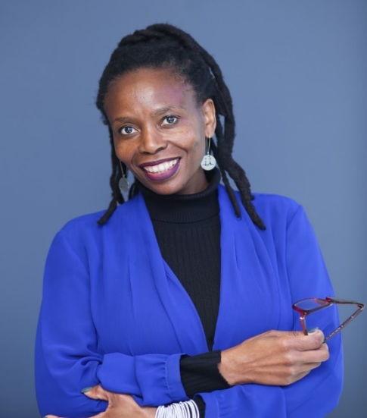

SESSION TWO
2:40pm to 3:30pm UK time

Room 1

Khyati Tripathi: COVID Dead Bodies in India: A Psychosocial Analysis.

Dead bodies, though, are perceived to be lacking any control or ‘agency’ as the mourners are the ones performing rituals for the deceased and taking care of the funeral (Tripathi, 2014) but it can also be argued that dead body exerts its power, control and agency through the rituals being executed by the mourners on its behalf. With coming of the COVID-19 pandemic, the way ‘infected’ dead bodies exert their agency has changed. In Hinduism, the identity markers that stay with the deceased are religion, age and sex because these three determine what death rituals would be followed. For the COVID bodies, on the other hand, primarily the COVID infection and then one’s religion become the primary identity markers. The ‘infection’ because that guides the logistics of the funeral process and ‘religion’ to ascertain if the body would be cremated or buried. This paper brings to the fore the comparison between pandemic and non-pandemic dead bodies through a psychosocial framework and explores how these bodies exert their power and agency on society at large.
The COVID dead bodies could further be divided into familiar (family/friends) or unfamiliar bodies. There is a lot of fear and stigma associated with the unfamiliar pandemic dead bodies. For example, the locals protested against the cremation of a doctor in Nellore, Andhra Pradesh, India who died of COVID treating his patients as the locals believed that the smoke will spread the infection (The Hindu, April 2020). The ‘unusualness’ of the infected dead makes humans behave as if they, the ‘alive ones’ can control them by not letting their funerals happen in their neighborhood and fail to realize that it is the fear of the ‘powerful dead’ that is projected onto the unfamiliar body as stigma.
For the present paper sixty three news reports (collected objectively from reliable sources) that explained stigma attached with the COVID dead bodies in terms of aversive reactions, mishandling of the bodies, reports of certain infected bodies being denied funerals, hospital staff refusing to touch the bodies and undignified funeral of the COVID dead, etc. were identified. Thematic analysis was carried out to ascertain different sub-themes under ‘stigma’ which were then understood within a psychosocial framework based on Freud’s (1919) concept of ‘The uncanny’ and Douglas’ (1970) ‘Body as a microcosm of society’.

Kanakis Leledakis: Bodies, Sociality and the Pandemic.

Being-in-relation- to- others is the primary (and only) way of constituting sociality i.e. the (individual) psyche as social. The physical distancing experienced in the pandemic along with the use of communication technology, raised the question of the importance/necessity of physical co-presence in the context of the relation to others.
(i) The relation to others has both a developmental aspect concerning the emergence of the self and an aspect concerning the functioning of the self in life in general. The lack of relations to others in early life annuls the very emergence of the self, while in later life is the origin of major psychological disruptions.
In the Freudian scheme a specific mechanism, that of identification, is presented as gradually building up the ego but also as present in adult life (as in the functioning of groups). Both the process of identification and the outcome of the process -what is internalized, the constitution of the ego- remain unconscious.
(ii) During the pandemic real-life, physical contact was severely limited. Instead, a contact mediated by media and technology became the norm for many. Technology, providing image and sound seemingly replaced physical contact in a relatively effective way. It raised the question of the whether e could, at least to some extent, replace physical co-presence.
An overriding sense was that communication through mobiles, platforms and the like are totally ineffective in replacing real, face- to- face contact. Lockdown was non bearable, not only because of the scarcity of contacts but also because of the inadequacy of technology mediated contacts.
(iii) Within a theorization of the psyche it is usually the type of relation to others -positive, negative- that was of concern, not whether it involved real physical contact. The experience of distant mediated communication poses forcefully the question of the physicality for the functioning of this relation. Stimulated human contact through electronic platforms and the profound sense of inadequacy it creates, indicates that real human contact operates through pathways beyond linguistic exchange.
Yet in psychological and especially psychoanalytic literature we do not have a theorization of exactly how -through which channels as it were- the 'others' have an impact on the self either in the early formative years or in everyday contact later. We take as given that human contact does create effects but do not theorize the 'medium(s)' this contact operates through.
It seems that psychoanalysis in general, while it does stress the inseparable /indissociable relation between affects and representations within the psyche as the outcome of processes such as identification, does not discuss at all at which level/through which medium(s) the relation to the other takes place. The experience of the lockdown allows us to explicitly pose the question of the medium.
A first remark would be that the way of connecting to others is only partially, or even minimally, linguistic. It does not concern the exchange of information, of communication in the informational theory sense. The sense of self-in-relation-to-others is created through channels which may employ language but also through other pathways to be specified.
Possibly, even probably, the notion of the unconscious in the Freudian sense, both topographically and as a mode of functioning, would be relevant to these pathways. To explore them could only lead to a better understanding also of the internal workings of the psyche.

Room 2

Ali Darke: Between Here And There.

Between Here and There introduces four cycles of my creative work, each evolving from the other, evoking a journey from the surface of the body to the depths. My art practice is interwoven with research in psychoanalytical theory. As I approach the final months of a Professional Doctorate in Fine Art I appreciate how the body has become implicated and integral to my process. Inner perception, creativity and psychoanalysis each inspire; performative embodiment connects me deeply to the work.
I created the “Wild Woman” during an artist’s’ residency and she has since haunted my being. Stepping onto the plinth and into the image, embodying the object of my work, provoked a profound response. Subject and object were fusing. Her presence evolved through characteristics of the witch, the Wilder Mann of European folk lore and my family’s history. Traces of trauma transmitted through the generations became apparent in my work. The psychosocial theories of post-memory enrich my enquiry.

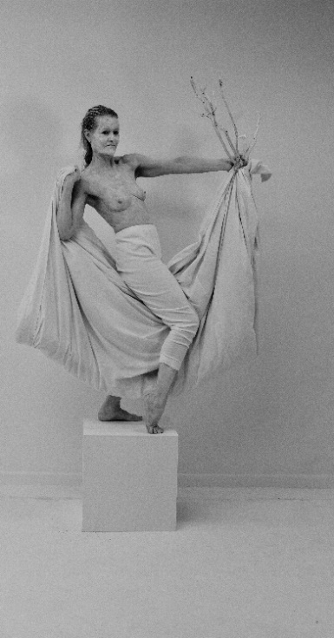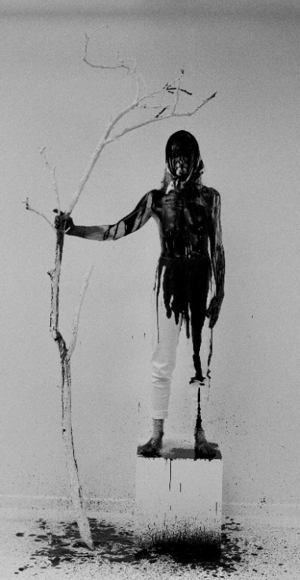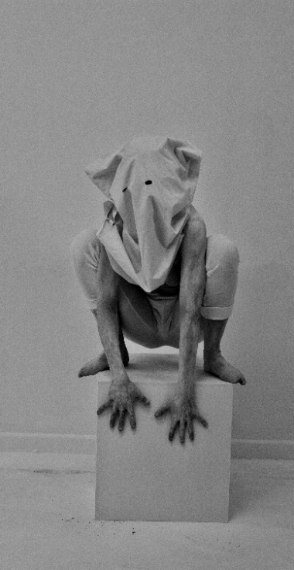
THE WILD WOMAN (2016)
To understand The Wild Woman’s ‘being’ more deeply, I look at the psyche’s topography of the body, mapped in space through the sensitivity of the skin, as it touches and is touched by the other and becomes a threshold for an alchemical exchange. I reflect on how the body is vibrantly woven, not only in the relationship between artist, object and viewer, but the very fabric of the art-work, to express profound trauma and existential angst, in the practice of Louise Bourgeois and Anthony Gormley. It is the body of the viewer that is drawn in to the encounter with the art of Doris Salcedo, and like the artist we contemplate the pain of others.
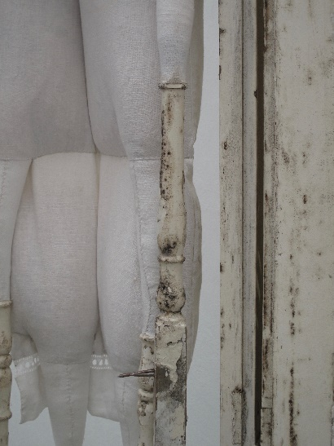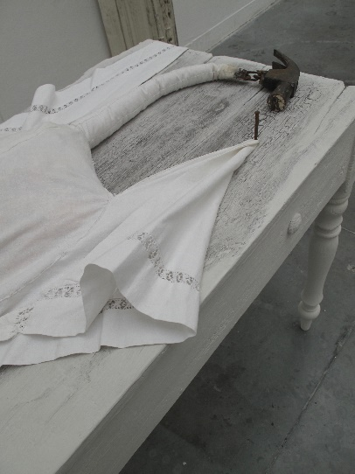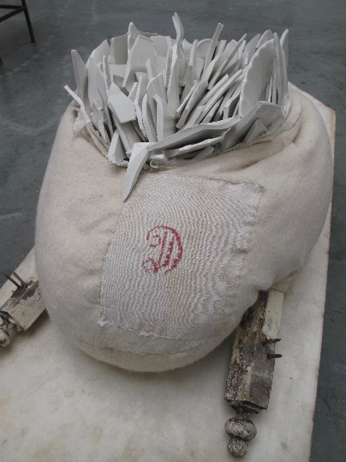
THE DEGENERATES (2019)
The Wild Woman exposed feelings of shame. Following this disturbing experience, I confronted Kristeva’s notion of the abject. In my next iteration of work, The Degenerates, I explore the tension between the bodily experience of entrapment and aspirations to flight. And finally, I delve into the inner life of the traumatised psyche and find the terrifying abject fragments of the ego described so evocatively by Dr Raluca Soreanu, that inspired my own vision of these ‘Psychic Fragments’.
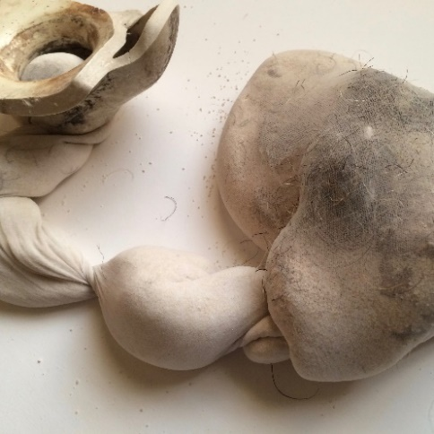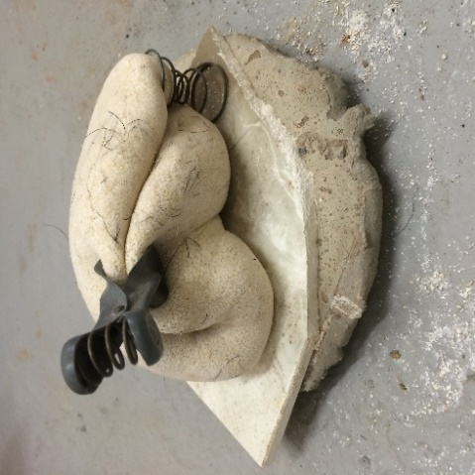
PSYCHIC FRAGMENTS: (2019)

Sebastian Birch: The Body and Cartographies of self-harm.

Deliberate self-harm, is a sub clinical event that as a mental health nurse I have encountered almost every of my clinical career. The understanding of the phenomena I find to be lacking.
Why is the body important for this study? The clinical interventions for self-harm are psychological. The focus on the intensity of emotions and the control of these. There is very little work to look at the Body itself in this process There is a paucity of interest in the Body. So, I ask again, why is the body important for this study?
Firstly, and rather obviously, we are looking at the clinical act of self-harm. We can theorise self-harm as the spilling out of the psychical onto the physical, onto the Body. The body becomes a map of the mental, it charts, historicises and records moments of intensity. Descartes makes his distinction between the mind and the body; self-harm destroys the distinction. So, the choice to leave the Body out of the discourse of its own cartography means we miss out on an integral part of the self-harm process. Areas of harm are chosen, quite rationally, to denote and communicate. The areas join and move with the inner states of intensity. Developing a deeper conceptual understanding of these maps will further our understanding of the whole phenomena and if we were so inclined, help to develop future interventions.
This paper will use the works of Guattari (2012) and Deligny (2014) to construct a theory, or at least to sketch a theory, of a cartography of self-harm. It will highlight the importance of the Body in therapeutics and aim to redress the logocentrism of mind over body in self-harm therapeutics. As we put the two together as a binary it becomes abundantly clear that mind and body are not opposed but are engaged in constant dialogue.

Room 3

Christa Welsh: A Blackgirl Autoethnography of Separation and Loss: Child-Shifting and Transgenerational Trauma.

In this embodied Endarkened Blackgirl autoethnography (Dillard and Okpalaoka 2013, Boylorn,2016 ) the author explores the essence of the embodied, felt, and lived experience of Child-Shifting and Transgenerational Trauma and offers psychological insights by bringing to life the prevalent issues of abandonment, hurt and loss through the lens of cultural representation (Hall, 2003) ‘endarkened’ epistemology (Dillard, 2002) and critical autoethnography (Adams, Holman Jones and Ellis 2015; Boylorn & Orbe, 20014; Maison 2012).
The author focuses retrospectively on selected epiphanies of home and social life in Grenada and the subsequent trauma of reunification (aged nine) with her mother and siblings in Britain. This study is informed by Womanist and Endarkened Feminist perspectives and attempts to be transparent and reflective while revealing other ways of knowing that challenges normative discourse and places Black women and their ways of knowing and knowledge production at the centre of analysis.
Through an intimate and vulnerable narrative (Ellis and Bochner 2000) attention is placed on understanding the ‘in between’ space of ‘not belonging fully either ‘there’ or here. In this way the author creates an individual and collective therapeutic space for listening to and understanding an ‘others’ lived experience and offers the transformative potential of moving from processes of ‘othering’ to a universalist position of compassion and humanity.

Mamatha Karollil: What the Ghost Wants: A Story of Intergenerational Secret-Keeping, Reckoning and Redemption in C Ayyappan’s “Spectral Speech”.

In C. Ayyappan’s “Spectral Speech”, a short-story from the Malayalam speaking state of Kerala in India, the ghost of a marginalized caste/dalit woman betrayed in love haunts the sister of her dominant caste lover. The ghost has a story to tell, of painful family secrets, of disavowed kinship lines between the masters and servants living under a roof. In this sense, as sociologists show, the secrets that family members conceal from one another are the erasures necessary for reinforcing contemporary social rules marking identity, relating and belonging. In another sense, as psychoanalysis shows, the speech of the ghost is like that of hidden, suppressed or violently oppressed selves) within one, finding articulation and voice through the symptoms marking the possessed body – the uncharacteristic voice, posture, deeds and the speech itself. This idea has found use in feminist analysis that attempts to recover the possessed body as a site of feminist resistance; under the ruse of possession, the female body experiences pleasurable transgression. Alternatively, feminists have also read rituals of exorcism as spectacles usefully deployed for a re-inscription of the heteronormative/ patriarchal social order.
This paper adds to and departs from such feminist (and psychoanalytic) analysis in two ways. First, in place of an analytic framework that examines the feminine subject’s relationship with the social, the paper looks at how the social is negotiated between people (of family members in this instance) via an inter-subjective and inter-corporeal transmission of unsymbolized family secrets. For this it draws from Abraham and Torok (1987) formulation of the ghost or the phantom as a ventriloquist speaking from the tomb housed within the unconscious of a loved one (a family member). Second, in widening the circuitry of unspeakable speech in such a triadic fashion, where the burdens of one’s family member are unconsciously shouldered by one, the paper raises questions about responsibility and accountability for structural violence. In this instance of a story of love, caste and gender oppression in India, ghostly possession becomes not only about the possessed claiming feminist agency, it is also about her guilt and an attendant bid for redemption.

SESSION THREE
4:10pm to 6:00pm UK time

Workshop 5

Leslie Thompson, Sophie Savage, Lita Crociani-Windland and Marilyn Charles: Enabling and disabling displacements in the mother/daughter relationships: embodying the reparation of formative experiences.

The conversation we are hoping to develop and cultivate in this panel focuses on the caring relationships between mothers and daughters. Each of us has different experiences to share and varying insight into the dynamics of this particular relationship. For each case we explore disability as a broad concept, as we are embodying, growing alongside and holding differing connections with disability, and the enabling and disabling influence upon each of us. As we traverse periods of intensive caring, albeit in different ways, we each offer our psychoanalytic and psycho-social translations as we unearth some of the processes involved in such a close familiar relationship between mothers and daughters. It becomes evident across our contributions and in the developing conversation that the concept of self has been shaped by the intensive formative experiences with our mothers. How we have each chosen to academically research such relationships binds us together as panel. The members of the panel are at different stages in life and in relation to their academic career. This panel is held together with both care, and pride - we are intensely invested in each other. It is apparent that such professional and personal relationships are akin to our formative ones in a special way. Thus we are presenting precisely what we are discussing, embodying the reparation of those formative relationships. We invite into this conversation anyone who has an interest in sharing and discussing formative relationships and the way the accompanying experience has shaped their sense of self - especially surrounding disability. As this is an emergent discussion, we would be grateful for any comments and questions.

Presentation 1: Mother and child absence and presence
The paper focuses on the displacement of the parental role in the lives of so called parental or parentified children. Taking as its start a scene from my own experience of becoming a parental child it goes on to speak of aspects of containment and the relative lack of attention in psychoanalysis to this aspect of experience. It ends by pointing to the need for more work in this area, particularly in terms of broadening the frame towards more psychosocial and transdisciplinary work that might inform therapeutic practice.

Presentation2: Becoming my mother’s eyes
Linking the person and the society, psycho-social studies is a discipline that goes from psychoanalysis to research and studies the ways in which psychic experience and social life are fundamentally entangled with each other. In this paper, I will explore the parallel process of how I became the mother of my mother as my mother struggled in the process of adjusting through acquired blindness, leading me to becoming blind to myself in order to see her and for her, and how that process was enhanced, if not created, through social components that surrounded our specific situation. Comments about society defining and creating disabilities, specifically blindness, will be made in the aim to understand the repetition that took place from society, through my extended family, to the core of the relationship between my mother and me.

Presentation 3: Intensive care, and institutionalisation: W(o/a)ndering for self.
Being in an intense mother/daughter relationship with my mother as my primary carer, often in a hospital far from home, distanced from outside support, dominated both our lives and could become the only focus leaving little space for anything or anyone else. In my presentation I will speak a little of my history of growing up with liver disease, and transplantation - but with a focus on the consequences of intensive caring within my relationship with my mother.

Being in a small shared space with ongoing trauma did not allow for emotions to be expressed in a healthy way, due to my fear of upsetting my mother and her concern of upsetting me. This changed the way we related to others, and how we were able or not able to express or process our shared and individual experiences of institutionalisation in an overcrowded children’s ward. There was a severe lack of privacy, my mother could never relax, so I didn’t learn how to either. There was no space to feel - so we compounded our repression into a tangle of unrelatable affect. My mother talked of an experience of walking and walking and walking away - just needed a total break, and she needed to know if she was still a human outside of the caring relationship - whether she was still a parent, or a human being, as I was left to wonder what it was be a child - and if I was human too. Without being given space - we are led to wander, to find spaces we were never given. The rhythm of our institutional life was relentless. I reflect on this in my contribution and it frames my perspective in our shared conversation on the enabling and disabling factors of the mother daughter relationship.

Presentation 4: Childhood and Memory: The River Running Through Us
Entering psychoanalysis invites us into the universe of childhood, memory, meanings,
and also the gaps left by trauma and neglect. In this presentation, I will explore ways in which my mother’s absent presence emerged and transformed over time. This transformation was made possible by psychoanalysis, self-analysis, and also through meeting my mother from the other side, so to speak, as I found myself at the other side of the various developmental precipices she and I had traversed together.

Workshop 6

Teresa Mason: The body politics of Sheela-na-gig.

Sheela-na-gig stone carvings, common in Ireland, invite a number of projections and potentially pose some interesting questions about the body. A key feature of these naked figures found on church and castle walls is display of the vulva. Generally regarded as dating from the 12th to 16th century, contemporaneous with the Norman settlement in Ireland, a number of scholars see connections with other images of 'sacred display' from around the world. Sheelas have variously been seen as in the throes of childbirth, in the act of masturbation, dancing or inviting sexual intercourse. She is also seen as aged or emaciated. This liminal figure is potentially symbolic of the ‘Great Mother’ archetype, invoking images of the goddess or the witch. However, she is also viewed as manifesting a 'sermon in stone' warning against the sin of lust, as having the ability to ward off the evil eye, as a good luck talisman for women in childbirth and in recent decades as an icon for Irish feminists. She has provided a rich source of inspiration for the arts and in particular the visual arts. The literature on Sheela-na-gig sees her as both Christian and pagan, grotesque, potentially subversive and as a welcome un-idealised visual female form. I am looking at the cultural politics surrounding Sheela-na-gig using Jungian and post- Jungian psychology with a focus on visual imagery. Jungian psychology has a particular affinity with visual symbols and increasingly Jungian and post-Jungian scholarly work is being used to examine arts practice and the cultural sphere. I propose to facilitate a median group for 15 to 20 people. Commencing with a presentation of visual text, I will invite participants of all genders to engage with the material and draw their own conclusions on her meaning and relevance to this contemporary moment.

If you would like to attend this workshop, please register here, with places being limited to 20.
Individuals attending this workshop are advised to have pen and paper (or other art materials if desired) to hand so you can make or write a response to the information presented.

Workshop 7

Ali Roy: A walk shop: invitation to an experiment in map making and mobile working

Recent years have seen a developing interest in walking as a research method, a form of arts practice, as well as a mode of therapeutic practice. Much of this interest in walking has focussed on walking in pairs or small groups and has been driven by the ways in which walking together can alter the relationship; and in a research context, by the possibility that it can open out new forms of research data. The Covid-19 pandemic has limited forms of human movement as a result of lockdowns and prohibitions on travel. It has also led to a greater interest in walking in public parks, paths and other spaces near where people live. This workshop is based on preliminary work I have done with colleagues which explores the possible research value of walking alone. It is designed around a set of simple instructions which encourage participants to complete a short map making and a walking exercise they complete by themselves near-by where they live. They are encouraged to draw a map before the walk. The idea is that the map making precedes the walk, but it does not have to lead or direct it in the way you might follow a route on an Ordnance Survey type map. After making the map, participants are asked to walk the route without the map and on returning home to add notes, drawings and/or photos to the map and add in any new associations and/or memories that come to them. In the workshop we will take time to present these to each other, allowing space for people to introduce their maps and walks as they choose, also allowing space for shared associations, connections and reflections and a short plenary discussion. It is fine for people who have not made maps or done walks to attend the workshop. We will use the exercise and the discussion to think together about whether working in this way allows us to learn anything new about our lives, concerns, homes, neighbourhoods. And we will reflect on what we liked/ or didn’t like about the process and whether there are better ways of sharing the material.

This workshop involves following instructions to make a map and complete a walk before the 9th July. If you would like to attend, please email Ali by 2nd July so that he can send you the materials: ANRoy@uclan.ac.uk

The Journal for Psychosocial Studies: Getting your Papers Published
6:10pm to 7:00pm UK time

This session will be delivered by David Jones and Elizabeth Frost who edit the APS Journal, with a focus on how to write for the journal and submission process. There will also be time for participants to ask questions.

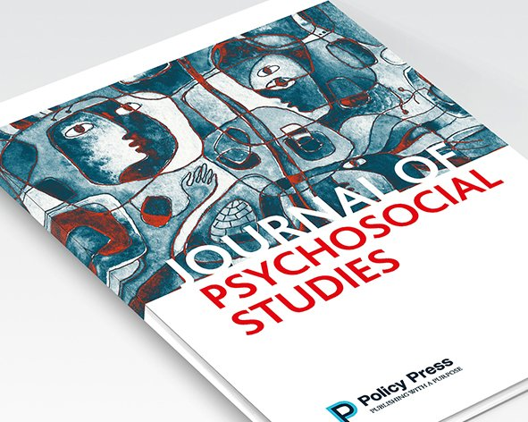

DAY FOUR – SATURDAY 10TH JULY.

Overview of Day

UK/PM Time | Session | Session
1:00 to 2:30 | Session 1 | Social Dreaming  Need to register | Workshop 8:  Activist Research Collective |  | Workshop 9:  Mila Kirstie Kulsa and Elan Cohen
2:40 to 3.30 | Session 2 | Room 1:  Dane Isaacs  Sasha Shestakova |  | Room 2:  Mauricio Baez  Julian Manley
3.30 to 4:00 | Break Activity | Moodle Interactive Content
4:10 to 5:00 | Session 3 | Room 1:  Trudi Macagnino  Julie Walsh, Poul Rohleder and Roisin Ryan-Flood
5:10 to 6:00 | Session 4 | Plenary

SESSION ONE
1:00pm to 2.30pm UK time

Social Dreaming – Lita Crociani-Windland and Nigel Williams
Social Dreaming workshops were originally developed by Gordon Lawrence as a means of consulting to organisations in a way which could go ‘beneath the surface’ to the unconscious preoccupations, images and phantasies that are ever-present but often unsurfaced in organisational life. Since then Social Dreaming has been developed in ways which take it outside of organisations and into community and community research. Social Dreaming is an experiential event in which we offer dreams and free associate to them to work towards a collective sense of patterns emerging from them. By pooling and connecting our dreams and associations we aim to ‘take the pulse’ of broader social realities and surface common concerns and creative possibilities.

The space for coming together to share and explore our dreams through an associative process is known as a 'matrix'. The word 'matrix' comes from the Latin for womb, and is used to denote a place of containment for creativity and emergence. A "host" provides support to the matrix, guiding our journey in sharing, associating to and making sense of our dreams. The word "host" is used to introduce the idea that the matrix is not a group to be facilitated or led but an open space for containing and working with dreams and associations.
The time is spent in two phases, an initial event in which participants share dreams and associations and a reflection event in which participants do sense making of the material that arose during the matrix. The total time of the event is 1.5 hrs. The dream matrix is roughly twice the time of the reflection.

Normally the event is held in a dedicated space with a particular arrangement of chairs, known as a snowflake pattern, which distinguishes it from other group relations events. In this time of social distancing the online event is held using Zoom. This gives a different challenge in that the physical arrangement facilitating the focus to be on dreams and not dreamers is not available. Please feel free not to use video if that becomes a distraction from the dream images being shared or the emergence of free associations to them, which are key to the event.

Event limited to 30 participants – if you would like to attend this workshop, please register here.

Workshop 8
1:00pm to 2:30pm

Activist Research Collective: "All Bodies Are Equal - embodied resistance and anti-oppressive practices"

In the UK, in the first two decades of this century, under the influence of neoliberal discourses of austerity and the Taylorisation of the hospital, health and social care policies and practices in the domain of 'mental health' have increasingly centred upon the bodies of the socially excluded. There tends increasingly to be 'no room at the inn' for minds that are suffering. Only an imperilled body may lay claim upon a bed (or a booth).

What this means in practice is that, for example, bodies have to reach a certain state of depletion or malnutrition before they can be accepted into 'eating disorder' services - and when they are thus accommodated, only the malnourished body will receive 'treatment' - the 'mind' must look elsewhere for healing.

To give another example, only an imperilled body may qualify for outpatient psychotherapy. Psychological therapies are increasingly clustered within 'complex needs services' that often will only see patients diagnosed with 'emotionally unstable personality disorder' who are 'cluster 8' - by which designation is signified 'at immediate and frightening risk of taking control of their bodies in unacceptable ways'. In other words, the signal reads, 'you have to inflict grievous or potentially lethal harm upon your own body before we'll organise ourselves to hear you out'.

This discussion group will present and debate material concerning bodies and particular experiences of multiplicity, as a means with which to bear witness to and illuminate marginalised and subjugated bodies of anti-oppressive practice and knowledge in response to the psy-industrial complex that dominates the system of care in late modernity.

The space will be facilitated by the Activist Research Collective (ARC), which is comprised of researchers with lived experience of mental health service use as well as traditional researchers, united in shared revolt against structures and processes that perpetuate discourses of domination and subjugation.

Workshop 9
1:00pm to 2:30pm

Mila Kirstie Kulsa and Elan Cohen: The abject body of the psychiatric sufferer: On the medicalization of suffering

The body of the psychiatric sufferer in Western society is necessarily abject. Drawing on theoretical arguments from Achille Mbembe’s (2003), notion of necropolitics, Nancy Scheper-Hughes’ (1997) description of rubbish people, and Giorgio Agamben’s (1998) notion of bare life, as well as Ranjana Khanna’s (2003) discussion of human disposability, Joao Biehl’s (2013) concept of social abandonment, and Zygmunt Bauman’s (2004) concept of wasted lives, I will explicate the intentionality of systems of care that seem premised on the capacity of societies to identify some categories of people as nonpersons, thereby eliminating the requirements of respect, dignity, and an invitation to narrative and agentic participation to which all humans would seem entitled. My particular interest is in a group that is extremely marginal in institutionalized health care systems, namely persons with chronic and severe psychiatric distress. This group has been and continues to be subject to violent and carceral regimes of treatment, and to pejorative labeling systems embodied in terms such as schizophrenia, borderline personality disorder, bipolar disorder etc., as well as to the construction of their subjectivities as diseased by the bitter pills of pharmaceutical regimens (cf., Burstow 2015; Fassin, 2011; Moncrieff, 2013; Whitaker, 2010). The writings of distinguished professors Lucy Newlyn (2018), Erin Soros (2015), and Ellyn Saks (2008), all psychiatric sufferers, illustrate the systemic misrecognition and violence too often at the heart of psychiatric “care” – a system that, as Farhdad Dalal (2018) documents, is increasingly enacting anti-human, managerial, neo-liberal systems of delivery (see also Vaspe, 2017).
Drawing on six years of field work with persons experiencing chronic psychiatric distress reported in my recent book (O’Loughlin et al, 2019), I will illustrate the working of these bioethical forces on a human scale. That field work draws on the concept of ethical loneliness, as discussed by Jill Stauffer. Stauffer argues that a sense of misrecognition is catastrophic for the psyche of a person who is in an extreme state and seeking holding, containment, or respite. The work also builds on Arthur Frank’s (1995) work on rupture and potential recovery, described in the The wounded storyteller. The mechanization and pharmaceucitalization of care and the absence of any opportunity for ethical listening in our participants’ lives was extremely troubling.
Presentation 2: The abject body of the psychiatric sufferer: Case explorations.
Drawing from clinical interviews collected by O’Loughlin et al. (2019), I present two cases of psychiatric patients which illustrate some of the complexities of the construction of subjectivity for persons inserted into the psychiatric care system, what Erving Goffman (1968) called a total institution. Equivalent to how the subjectivities of consumers are discursively shaped by corporations, the subjectivities of psychiatric patients become covertly shaped by the medicalized and bureaucratized notions of being through every interaction as they receive psychiatric treatment. Whether an individual experiences one catastrophic, precipitous event or an accumulation of traumatic stressors over time, life is interrupted by a psychiatric rupture (O’Loughlin et al., 2019), psychic distress that Donald Winnicott (1989) called an extreme defense. Possibly due to a lack of a holding environment (Winnicott, 1965) or intergenerational trauma (Davoine & Gaudillière, 2004; Winnicott, 1974), these idiosyncratic life ruptures result in the failures of individuals’ capacities to exist as productive, self-sufficient members of society – failures which subsequently lead to the inaccurate perception of these patients as “non-normative Others” (O’Loughlin, 2002) who are beyond rehabilitation.
As O’Loughlin (2002) described, the psychiatric institutional system is designed to “name, identify, classify, domesticate and contain” (p. 177) a psychiatric patient’s experience so that it is encapsulated into an entity that is ostensibly diagnosable. Once immersed into the small society of a psychiatric hospital (Caudill, 1958), patients adopt specific, cultural scripts – both spoken and unspoken – and, therefore, become subjected to what Jacques Lacan (1997) deemed as the symbolic of the system itself. To understand how the interpersonal relationships, communications, frameworks for thinking, ascribed labels, and provided solutions within the psychiatric system have shaped Jaime’s and Mary’s understandings of their places in the world, I frame this exploration around the following questions: What are these women’s experiences with psychiatric treatment and conceptions of their own psychic distress? How have their subjectivities been shaped by hospitalization, diagnostic frameworks, pharmaceutical, and medicalized conceptions of psychic suffering? Furthermore, how have they incorporated the system’s frameworks and disavowal of their agency into their own narratives?
Presentation 3: Neuroleptic use and the bodies of long-term psychiatric sufferers.
The bodies of long-term psychiatric patients in state hospitals and sheltered housing are often subjected to regimes of excessive neuroleptic drugging, producing substantial iatrogenic morbidity and mortality. Although the adverse health costs of long-term neuroleptic use are well-documented (Whitaker, 2016), bio-psychiatric discourse tends to construe them as side effects of a medically necessary treatment. Objection to this formulation by critical psychiatrists and psychoanalysts, ex-patients, and psychiatric survivors sheds light on the social use of neuroleptics as chemical straitjackets, which subdue the superficial manifestations of severe psychic distress. Critics of the overuse of neuroleptics in institutional settings highlight their ability to induce states of placidity and indifference (Moncrieff, 2016), thereby deadening the signals of distress rather than locating their source. Conspicuously, detractors of biological psychiatry argued that the introduction of neuroleptics in the 1950s exchanged the noise of the asylum for the silence of the cemetery (Healy, 2004). This is particularly striking in light of Foucault’s commentary on medical epistemology, which posits that the body is “a temporarily animated corpse made of interchangeable parts,” thereby positioning medicine as a field concerned with controlling and manipulating the material of bodies to achieve desired effects (Piemonte, 2018). However, a psychoanalytic understanding of the body of the psychiatric sufferer as the refuge of cut out, unspeakable historical truths (Davoine and Gaudilliere, 2004), suggests that the suppression of the bodies of psychiatric patients with neuroleptics may bear ethical significance that transcends debates about individual health and wellness. This presentation will explore Davoine and Gaudilliere’s socio-historically situated view of the body in relation to clinical examples from my work on long-term inpatient psychiatric units and community mental health settings, as well as the role of neuroleptics in psychiatric treatment.

SESSION TWO
2:40pm to 3:30pm UK time

Room 1

Dane Isaacs: “Stammering less so that I can be more of a man”: Discourses of Masculinities Amongst Young Adult Men in the Western Cape who Stutter.

The past three decades or so has seen researchers increasingly examine masculinities within the context of disability. A number of these studies, however, examined masculinities and physical disability in general terms. There remains a gap in impairment-specific research. The present study seeks to examine the discourses of masculinities amongst young adult men in the Western Cape Province who stutter. Presently, no international and South African studies have explored the gender experiences of men who stutter. The prevalence of stuttering is around four times greater in males than females. In South Africa, approximately 400 000 people stutter and 80% of adults who stutter are men. Semi-structured interviews and focus groups were used to collect data from 15 men who stutter. In analysing the data, a combination of discursive and applied psychoanalytical perspectives were employed. Specific attention was given to the emotional processes that men go through in resisting, subverting and challenging dominant norms of masculinity. The findings revealed that men predominately drew on hegemonic norms to construct their masculinities, emphasizing the importance of occupying a position and control, especially when interacting with other heterosexual men and potential dating and sexual partners. Men at times also presented contrary and competing subject positions, simultaneously accepting and rejecting certain practices of dominant masculinity in their daily lives, specifically in relation to female figures (such as mothers and friends) and homosexual men. It was evident that the process of negotiating all these multiple versions of masculinity was not easy. At times, men indicated struggling to negotiate their stutter with dominant masculine ideals, which led to reduced self-esteem and self-confidence, and negative emotions and feelings of shame, weakness, emasculation and inadequacy. In instances where participants resisted hegemonic ideals, they formulated alternative masculinities in line with their impairment. Implication for future masculinities research in the context of disability are discussed.

Sasha Shestakova: Other reproductive technologies

The reproductive technologies are commonly discussed as so-called artificial wombs, which can independently nurse babies. However, as Irina Aristarkhova points out, the labour of nourishing and caring is performed by an alliance of both humans and non-humans. In the case of “artificial” gestation it is often the labour of nurses, who maintain the well-being of a new-born child, which is not counted as existent. In my essay, I intend to focus on the labour of maintenance and care, which constitutes “distributed reproduction” (Murphy, 2013). This term was introduced by critical infrastructures studies scholar Michelle Murphy, who defined it as “reproduction occurring beyond bodies with uneven spatial and temporal infrastructures”(Murphy, 2013), she defines infrastructures not solely as “physical structures of waterway and pipeline”, but as “spatially and temporally extensive ways that practices are sedimented into and structure the world” (Murphy, 2013),. Following this theoretical framework, combined with process oriented approaches to care, proposed by both Irina Aristarkhova and Maria Puig de la Belacassa, I intend to discuss the practices of creation of alternative futures through acts of maintenance and care in Russia and Kyrgyzstan.
I intend to start by discussing the practices of Cyberfeminists in Russia in 1990s. Firstly, discuss practices of collective care for children alongside the historical theoretisations of collective care for children, done by Soviet feminist Alexandra Kolontai. Then I will discuss the pedagogical practices of cyberfeminist, which were aimed at the formation of infrastructures of global connection. They were teaching members of women organisations in St.Petersburg to create their websites as well as to use e-mail. Then the pedagogical practices of cyberfeminists were moved towards teaching women technical skills. I will discuss the differentiated futures, which these practices facilitated.
I will move on to discussing a more recent, and more speculative initiative: the collection of SF stories, written by feminist, queer and environmental activists “Completely other”, published by the Shtab initiative in Bishkek, Kyrgyzstan. Many contributors to this volume had never had the experience of fiction writing before contributing to the book, however they had had the experience of thinking “what counts as future” (Ballestero, 2019. 41). I will look at the collection as an infrastructure for multiple futures to emerge, considering the practice of writing as the practice of maintenance of an infrastructure. This perspective on fiction would not consider it as imaginations of end-results, but rather as one of the practices of “creating difference without radical alterity”(Ballestero, 2019. 41).
Finally, having considered these case studies, I will reconsider the definition of “reproductive technologies” and try define it not as a set of devices, but rather as a multitude of practices.

Room 2

Mauricio Baez: The Faces as the most Dramatic Bodies.

Despite its ubiquitous presence and our inclination to recognize it, the relevance of faces go almost unnoticed by our consciousness. However, faces can be expressive in such intensity that just a smirk can ruin a day, or our eyes can expose us with a single look. Our faces have the capacity to affect and to be affected in such ways that they are different from spatial actions or conceptual developments. If we follow Deleuze's theory, faces compose a world before any action, a pure world of affective expression. What happens to that world when all of us are wearing masks? Can the digital versions of our faces replace our physical gestures? What does it mean to cover up our faces during economic, health, and social crises? The object of this paper is to outline key elements from an autoethnographic undertook through the lockdown and the concept of face, based on Deleuze and affective theory. Through this, it is possible to observe some social layers of our current life and how it has been affected by COVID-19. The pandemic has arguably mobilized our passions, and many people have been affected in new ways. The reported (hi)stories about coronavirus, its meaning and what we should feel about it are performed in front of us and become imperative for our daily lives. However, the notion of a crisis is not the same for all of us. Many of us before the emergence of this virus were excluded from any public space associated with work in Bogota, Colombia. This means that, for many of us, the “lockdown” started years ago, but the passions connected to exclusions have changed nowadays. How have we assimilated those new impacts and what new passions have emerged?

Julian Manley: The Social Dreaming Matrix as a Body Without Organs.

This presentation explores the ways that Deleuzian philosophy can help to inform the understanding and application of social dreaming as a psycho-social method/practice. It follows on from detailed work that I have published in this field to date (Manley 2018; Long and Manley 2019). Despite a renewed interest in Deleuzian approaches in the psycho-social, especially with regard to an increasing interest in the concept of ‘affect’ and the meaning of terms such as the Deleuzian ‘rhizome’ and ideas of ‘becoming’, many psycho-social academics still view Deleuze and Guattari with suspicion. Their work is still seen as murky and unhelpfully anti-psychology, even though their seminal text – Anti-Oedipus (1999) – was anti-Freudian, rather than anti-psychology. Social dreaming began life as an anthropological experiment in the sharing of dreams in the 1930s in Germany (Beradt 1985), inspiring Gordon Lawrence to create a dream sharing space as an alternative to Tavistock psychodynamic groups (Lawrence 1988). For many years, social dreaming was understood in terms of the application of Bion and Winnicottian theory. Even though Bion was not against a view of the unconscious as benign, as opposed to an indicator of repression, the emphasis on his theory in the context of a Tavistock framework meant that it was difficult to understand many aspects of social dreaming that did not fit in with Bion’s psychodynamic theory. It was only after the passing of Lawrence (Manley 2014) that new ways of considering social dreaming have been given a space for an alternative positioning of social dreaming. Deleuzian thought is one of these; another is the work of Charles Peirce (Long and Manley 2019). In both cases, thinkers are looking to philosophy to help expand our knowledge of social dreaming, especially the uncanny sense of creativity, emergence, ‘sharedness’ and openness to possibility that are so much features of the social dreaming matrix. In this presentation, I take on board one of Deleuze’s most complex ideas, the Body Without Organs to explain some of the specific nature of the experience of social dreaming, especially the oft cited but little explained idea of Lawrence’s interest in the ‘dream and not the dreamer’.

SESSION THREE
4:10pm to 5:00pm UK time

Trudi Macagnino: Online psychosocial interviewing: An out-of-body experience?

This article is my first person experience of conducting free-association narrative interviews (FANI) online due to the COVID pandemic. The interviews were conducted as part of my PhD research into how our relationship with the natural world and concerns about the Climate and Ecological Emergency present themselves within a therapeutic context. My experience is pertinent to the theme of the conference as my body and my subjects’ bodies were not together in the same physical space.
FANI is a well-recognised and used method within psychosocial research but is typically conducted in co-present interviews; interviewer and interviewee meet in person. Guidance on how to adapt the method to an online environment is lacking. Research does exist examining online psychoanalytic therapy interactions and some of this is applicable to psychosocial interview methods. My experience is examined in the context of this research and goes further to suggest practical adaptations for psychosocial researchers as opposed to therapists.
I found online interviewing to be different and unequivalent to co-present interviewing. The missing of the others’ body was a significant part of my experience. As a result, I made various adaptations, many unconscious at the time and only apparent on reflection. Although there are losses involved in online interviewing, I found it still possible to acquire rich data.
It is likely that working remotely will continue to be commonplace as the pandemic has highlighted the potential benefits. I hope that other psychosocial researchers find my experiences helpful when adapting to online interviewing.

Julie Walsh, Poul Rohleder and Róisín Ryan-Flood: Holding Hands: LGBTQ relationships and experiences of shame, pride and protest in everyday spaces.

Many LGBTQ individuals grow up with a sense of being ‘other’ in a heteronormative society. This is not just an internal, psychological experience, as many LGBTQ individuals report being recipients of hostility, victimisation and harassment. Interpersonally, homophobia and transphobia (both actual and fear of) may play out between partners and inhibit partners from commonplace displays of affection (e.g. holding hands in public). Holding hands in public, a taken-for-granted act of interpersonal affection for many heterosexual couples, may carry particular anxieties and/or significance for LGBTQ partners. Holding hands may be experienced with feelings of anxiety, shame and fear, or, conversely, may be regarded as a significant and meaningful act of pride and/or resistance. To explore participants personal experiences of this, the project is utilising a participatory, creative research approach. The project involves the following components: Study participants are invited to produce images (e.g. photographs or drawings) that symbolise and represent their experiences, and to use these images as a point of discussion in individual interviews. Further data is also being collected by inviting participants to conduct audio-recorded friendship conversations with a close friend about this topic. This seminar will present some preliminary findings from this research, which is funded by the British Academy.

PLENARY
5:10pm to 6:00pm UK time

As the APS 2021 conference closes, we would like to invite all participants to the final session where we can reflect on emerging themes and think together about our work going forward. Even in the uncertain times of COVID, we would welcome new ideas and topics for the APS conference and events team to take forward in 2022.
The plenary will be in the form of small breakout groups with a facilitator and rapporteur, before we come together as a collective. This session will be chaired by Lynn Froggett and Lindsey Nicholls.

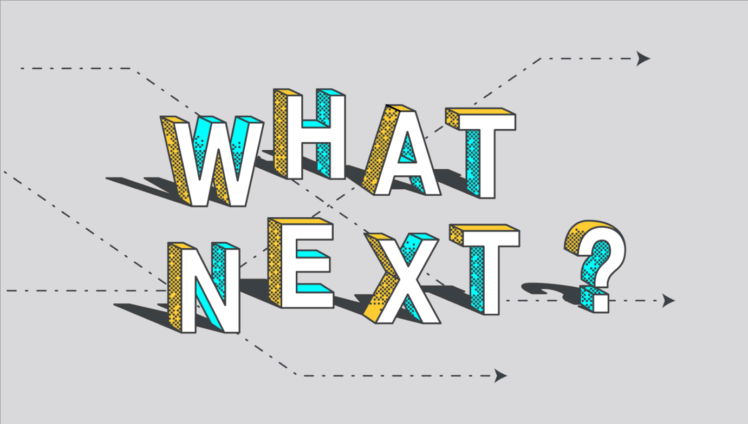

FEEDBACK

Thank you for attending the 2021 APS Psychosocial Bodies Conference.
The conference committee hope you found the conference engaging, stimulating and reflective of the times.
To help reflect upon the conference and improve future APS events, could you please take the time to complete this short survey:
APS Psychosocial Bodies Conference Feedback
If you are unable to access the survey or would like to provide feedback in a different format, please contact Sarah Shorrock:
SShorrock1@uclan.ac.uk

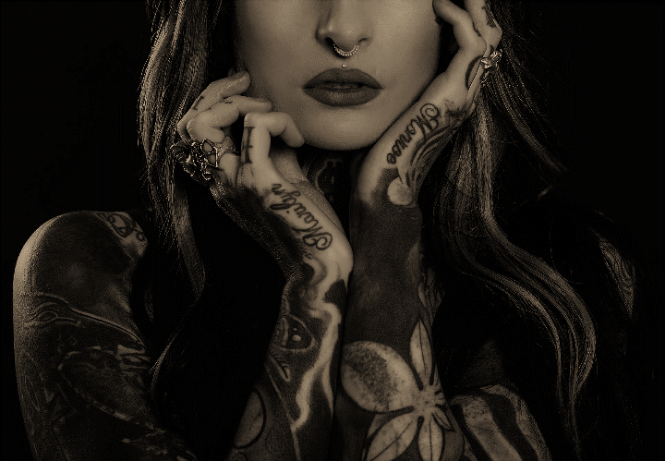

A phenomenon familiar to African diaspora communities where children are shifted between relatives, extended family friends (Russell-Brown et al 1997).

